Schema Afskrift.Folketing.LexDania_2.1.xsd

schema location: | V:\LexDania\Current\Folketinget\Afskrift.Folketing.LexDania_2.1.xsd
attribute form default: | unqualified
element form default: | qualified

Elements | Complex types
Dokument | Dokument_type

schema location: | V:\LexDania\Current\Folketinget\Folketing.LexDania_2.1.xsd
attribute form default: | unqualified
element form default: | qualified

Attributes | Elements | Complex types | Attr. groups
abbr | Aktivitet | Aktivitet_type | tableAtt_group
align | DagsordenPlan | DagsordenPlan_type | tdAtt_group
alt | DagsordenPunkt | DagsordenPunkt_type | thAtt_group
axis | DagsordenUnderpunkt | DagsordenUnderpunkt_type | trAtt_group
bgcolor | Image | Image_type
border | PreTekst | PreTekst_type
cellpadding | PunktTekst | PunktTekst_type
cellspacing | SagAnmeldelse | SagAnmeldelse_type
class | SkriftligBegrundelse | SkriftligBegrundelse_type
colspan | Table | Table_type
height | Tale | Tale_type
name | Taler | Taler_type
rowspan | TalerTitel | TaleSegment_type
scope | TaleSegment | Td_type
src | TaleType | TekstGruppe_type
style | Td | Th_type
summary | TekstGruppe | TitelGruppe_type
urn | Th | Tr_type
valign | Titel
width | TitelGruppe
 | Tr
 | UnderTitel

schema location: | V:\LexDania\Current\Folketinget\LexDania_2.1.xsd
attribute form default: | unqualified
element form default: | qualified

Attributes | Elements | Complex types
adjunctio | Arca | Arca_type
formaChar | Char | Char_type
formaEx | Exitus | Exitus_type
formaForma | Explicatus | Figura_type
formaInd | Figura | Indentatio_type
formaNo | Indentatio | Index_type
id | Index | Linea_type
lingua | Linea | Nota_type
REFid | Nota | Rubrica_type
signiChar | NotaPrivata | Tabula_type
 | Rubrica | Xtern_type
 | Tabula

schema location: | V:\LexDania\Current\Folketinget\MetaFolketing.LexDania_2.1.xsd
attribute form default: | unqualified
element form default: | qualified

Attributes | Elements | Groups | Complex types
tingdokID | AudioFileFolder | FTCase_group | MetaCaseNotice_type
 | DateOfSitting | StartEndDateTime_group | MetaFTAgendaItem_type
 | EdixiDocLocation |  | MetaFTAgendaSubItem_type
 | EdixiStatus |  | MetaMeeting_type
 | EndDateTime |  | MetaSpeakerMP_type
 | FTCase |  | MetaSpeechSegment_type
 | FTCaseNumber
 | FTCaseStage
 | FTCaseType
 | GroupNameShort
 | ItemNo
 | JointReadingID
 | LastModified
 | Location
 | MeetingNumber
 | MetaCaseNotice
 | MetaFTAgendaItem
 | MetaFTAgendaSubItem
 | MetaMeeting
 | MetaSpeakerMP
 | MetaSpeechSegment
 | OratorFirstName
 | OratorLastName
 | OratorRole
 | ParliamentaryGroup
 | ParliamentarySession
 | ShortTitle
 | StartDateTime
 | SubItemNo

element Dokument
diagram
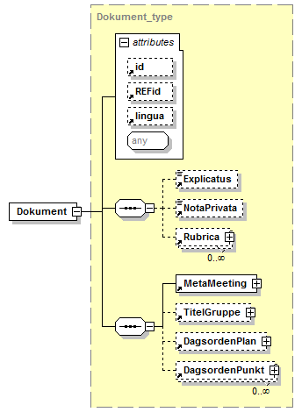
type
Dokument_type
properties
content | complex
id | Dokument_2.1-Dokument
children
Explicatus NotaPrivata Rubrica MetaMeeting TitelGruppe DagsordenPlan DagsordenPunkt
attributes
Name | Type | Use | Default | Fixed | annotation
id
REFid
lingua
source
<xsd:element name="Dokument" type="Dokument_type" id="Dokument_2.1-Dokument"/>

complexType Dokument_type
diagram
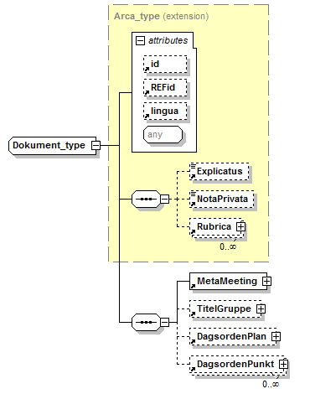
type
extension of Arca_type
properties
base | Arca_type
id | Dokument_type_2.1-Dokument
children
Explicatus NotaPrivata Rubrica MetaMeeting TitelGruppe DagsordenPlan DagsordenPunkt
used by
element | Dokument
attributes
Name | Type | Use | Default | Fixed | annotation
id
REFid
lingua
source
<xsd:complexType name="Dokument_type" id="Dokument_type_2.1-Dokument">
<xsd:complexContent>
<xsd:extension base="Arca_type">
<xsd:sequence>
<xsd:element ref="MetaMeeting"/>
<xsd:element ref="TitelGruppe" minOccurs="0"/>
<xsd:element ref="DagsordenPlan" minOccurs="0"/>
<xsd:element ref="DagsordenPunkt" minOccurs="0" maxOccurs="unbounded"/>
</xsd:sequence>
</xsd:extension>
</xsd:complexContent>
</xsd:complexType>

attribute abbr
type
xsd:string
properties
id | abbr_2.1-Folketing
used by
attributeGroups | tdAtt_group thAtt_group
source
<xsd:attribute name="abbr" type="xsd:string" id="abbr_2.1-Folketing"/>

attribute align
type
restriction of xsd:string
properties
id | align_2.1-Folketing
used by
attributeGroups | tableAtt_group tdAtt_group thAtt_group trAtt_group
facets
enumeration | left
enumeration | center
enumeration | right
source
<xsd:attribute name="align" id="align_2.1-Folketing">
<xsd:simpleType>
<xsd:restriction base="xsd:string">
<xsd:enumeration value="left"/>
<xsd:enumeration value="center"/>
<xsd:enumeration value="right"/>
</xsd:restriction>
</xsd:simpleType>
</xsd:attribute>

attribute alt
type
xsd:string
properties
id | alt_2.1-Folketing
used by
complexType | Image_type
source
<xsd:attribute name="alt" type="xsd:string" id="alt_2.1-Folketing"/>

attribute axis
type
xsd:string
properties
id | axis_2.1-Folketing
used by
attributeGroups | tdAtt_group thAtt_group
source
<xsd:attribute name="axis" type="xsd:string" id="axis_2.1-Folketing"/>

attribute bgcolor
type
xsd:string
properties
id | bgcolor_2.1-Folketing
used by
attributeGroups | tableAtt_group tdAtt_group thAtt_group trAtt_group
source
<xsd:attribute name="bgcolor" type="xsd:string" id="bgcolor_2.1-Folketing"/>

attribute border
type
xsd:string
properties
id | border_2.1-Folketing
used by
complexType | Image_type
attributeGroup | tableAtt_group
source
<xsd:attribute name="border" type="xsd:string" id="border_2.1-Folketing"/>

attribute cellpadding
type
xsd:string
properties
id | cellpadding_2.1-Folketing
used by
attributeGroup | tableAtt_group
source
<xsd:attribute name="cellpadding" type="xsd:string" id="cellpadding_2.1-Folketing"/>

attribute cellspacing
type
xsd:string
properties
id | cellspacing_2.1-Folketing
used by
attributeGroup | tableAtt_group
source
<xsd:attribute name="cellspacing" type="xsd:string" id="cellspacing_2.1-Folketing"/>

attribute class
type
xsd:string
properties
id | class_2.1-Folketing
used by
attributeGroup | tableAtt_group
source
<xsd:attribute name="class" type="xsd:string" id="class_2.1-Folketing"/>

attribute colspan
type
xsd:string
properties
id | colspan_2.1-Folketing
used by
attributeGroups | tdAtt_group thAtt_group
source
<xsd:attribute name="colspan" type="xsd:string" id="colspan_2.1-Folketing"/>

attribute height
type
xsd:string
properties
id | height_2.1-Folketing
used by
complexType | Image_type
attributeGroups | tableAtt_group tdAtt_group
source
<xsd:attribute name="height" type="xsd:string" id="height_2.1-Folketing"/>

attribute name
type
xsd:string
properties
id | name_2.1-Folketing
used by
complexType | Image_type
source
<xsd:attribute name="name" type="xsd:string" id="name_2.1-Folketing"/>

attribute rowspan
type
xsd:string
properties
id | rowspan_2.1-Folketing
used by
attributeGroups | tdAtt_group thAtt_group
source
<xsd:attribute name="rowspan" type="xsd:string" id="rowspan_2.1-Folketing"/>

attribute scope
type
restriction of xsd:string
properties
id | scope_2.1-Folketing
used by
attributeGroups | tdAtt_group thAtt_group
facets
enumeration | row
enumeration | col
source
<xsd:attribute name="scope" id="scope_2.1-Folketing">
<xsd:simpleType>
<xsd:restriction base="xsd:string">
<xsd:enumeration value="row"/>
<xsd:enumeration value="col"/>
</xsd:restriction>
</xsd:simpleType>
</xsd:attribute>

attribute src
type
xsd:string
properties
id | src_2.1-Folketing
used by
complexType | Image_type
source
<xsd:attribute name="src" type="xsd:string" id="src_2.1-Folketing"/>

attribute style
type
xsd:string
properties
id | style_2.1-Folketing
used by
attributeGroups | tableAtt_group tdAtt_group thAtt_group trAtt_group
source
<xsd:attribute name="style" type="xsd:string" id="style_2.1-Folketing"/>

attribute summary
type
xsd:string
properties
id | summary_2.1-Folketing
used by
attributeGroup | tableAtt_group
source
<xsd:attribute name="summary" type="xsd:string" id="summary_2.1-Folketing"/>

attribute urn
type
xsd:string
properties
id | urn_2.1-Folketing
source
<xsd:attribute name="urn" type="xsd:string" id="urn_2.1-Folketing"/>

attribute valign
type
restriction of xsd:string
properties
id | valign_2.1-Folketing
used by
attributeGroups | tdAtt_group thAtt_group trAtt_group
facets
enumeration | top
enumeration | middle
enumeration | bottom
source
<xsd:attribute name="valign" id="valign_2.1-Folketing">
<xsd:simpleType>
<xsd:restriction base="xsd:string">
<xsd:enumeration value="top"/>
<xsd:enumeration value="middle"/>
<xsd:enumeration value="bottom"/>
</xsd:restriction>
</xsd:simpleType>
</xsd:attribute>

attribute width
type
xsd:string
properties
id | width_2.1-Folketing
used by
complexType | Image_type
attributeGroups | tableAtt_group tdAtt_group
source
<xsd:attribute name="width" type="xsd:string" id="width_2.1-Folketing"/>

element Aktivitet
diagram
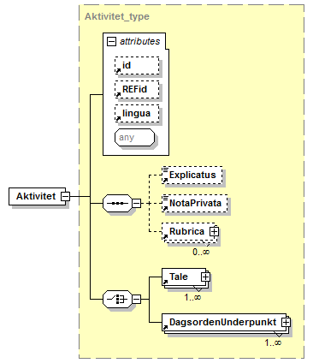
type
Aktivitet_type
properties
content | complex
id | Aktivitet_2.1-Folketing
children
Explicatus NotaPrivata Rubrica Tale DagsordenUnderpunkt
used by
complexType | DagsordenPunkt_type
attributes
Name | Type | Use | Default | Fixed | annotation
id
REFid
lingua
source
<xsd:element name="Aktivitet" type="Aktivitet_type" id="Aktivitet_2.1-Folketing"/>

element DagsordenPlan
diagram
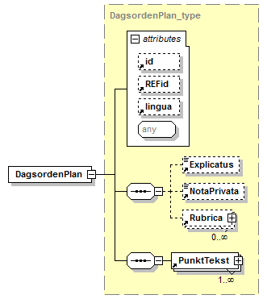
type
DagsordenPlan_type
properties
content | complex
id | DagsordenPlan_2.1-Folketing
children
Explicatus NotaPrivata Rubrica PunktTekst
used by
complexType | Dokument_type
attributes
Name | Type | Use | Default | Fixed | annotation
id
REFid
lingua
source
<xsd:element name="DagsordenPlan" type="DagsordenPlan_type" id="DagsordenPlan_2.1-Folketing"/>

element DagsordenPunkt
diagram
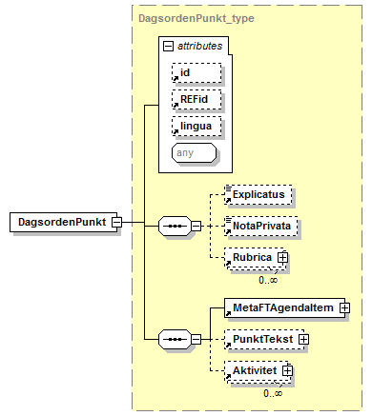
type
DagsordenPunkt_type
properties
content | complex
id | DagsordenPunkt_2.1-Folketing
children
Explicatus NotaPrivata Rubrica MetaFTAgendaItem PunktTekst Aktivitet
used by
complexType | Dokument_type
attributes
Name | Type | Use | Default | Fixed | annotation
id
REFid
lingua
source
<xsd:element name="DagsordenPunkt" type="DagsordenPunkt_type" id="DagsordenPunkt_2.1-Folketing"/>

element DagsordenUnderpunkt
diagram
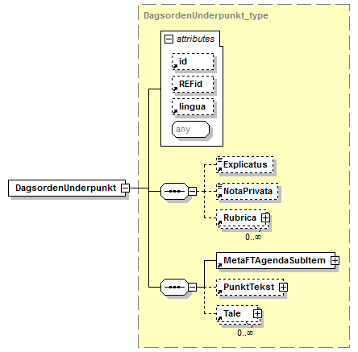
type
DagsordenUnderpunkt_type
properties
content | complex
id | DagsordenUnderpunkt_2.1-Folketing
children
Explicatus NotaPrivata Rubrica MetaFTAgendaSubItem PunktTekst Tale
used by
complexType | Aktivitet_type
attributes
Name | Type | Use | Default | Fixed | annotation
id
REFid
lingua
source
<xsd:element name="DagsordenUnderpunkt" type="DagsordenUnderpunkt_type" id="DagsordenUnderpunkt_2.1-Folketing"/>

element Image
diagram
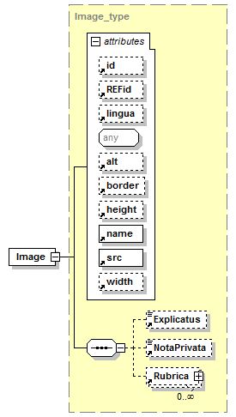
type
Image_type
properties
content | complex
substGrp | Figura
id | Image_2.0-Folketing
children
Explicatus NotaPrivata Rubrica
attributes
Name | Type | Use | Default | Fixed | annotation
id
REFid
lingua
alt
border
height
name |  | required
src |  | required
width
source
<xsd:element name="Image" type="Image_type" substitutionGroup="Figura" id="Image_2.0-Folketing"/>

element PreTekst
diagram
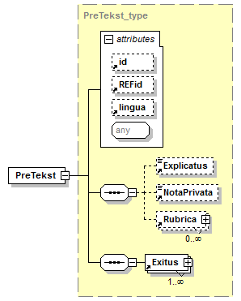
type
PreTekst_type
properties
content | complex
id | PreTekst_2.1-Folketing
children
Explicatus NotaPrivata Rubrica Exitus
used by
complexType | PunktTekst_type
attributes
Name | Type | Use | Default | Fixed | annotation
id
REFid
lingua
source
<xsd:element name="PreTekst" type="PreTekst_type" id="PreTekst_2.1-Folketing"/>

element PunktTekst
diagram
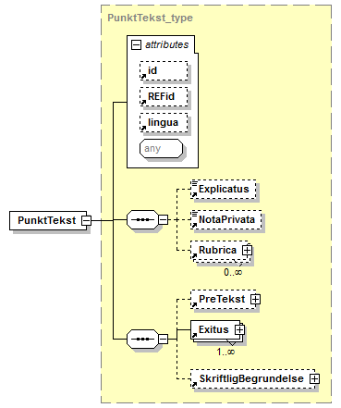
type
PunktTekst_type
properties
content | complex
id | PunktTekst_2.1-Folketing
children
Explicatus NotaPrivata Rubrica PreTekst Exitus SkriftligBegrundelse
used by
complexTypes | DagsordenPlan_type DagsordenPunkt_type DagsordenUnderpunkt_type
attributes
Name | Type | Use | Default | Fixed | annotation
id
REFid
lingua
source
<xsd:element name="PunktTekst" type="PunktTekst_type" id="PunktTekst_2.1-Folketing"/>

element SagAnmeldelse
diagram
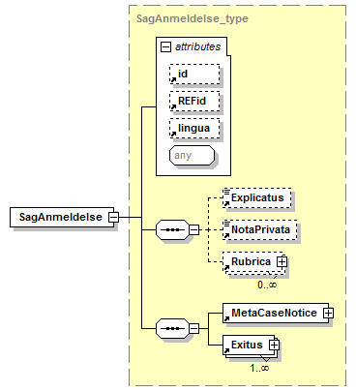
type
SagAnmeldelse_type
properties
content | complex
id | SagAnmeldelse_2.1-Folketing
children
Explicatus NotaPrivata Rubrica MetaCaseNotice Exitus
used by
complexType | TaleSegment_type
attributes
Name | Type | Use | Default | Fixed | annotation
id
REFid
lingua
source
<xsd:element name="SagAnmeldelse" type="SagAnmeldelse_type" id="SagAnmeldelse_2.1-Folketing"/>

element SkriftligBegrundelse
diagram
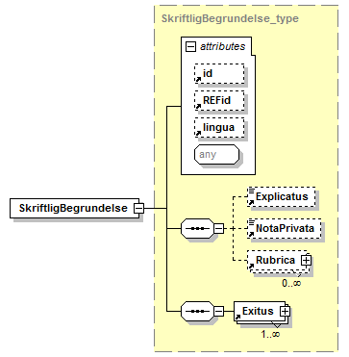
type
SkriftligBegrundelse_type
properties
content | complex
id | SkriftligBegrundelse_2.1-Folketing
children
Explicatus NotaPrivata Rubrica Exitus
used by
complexType | PunktTekst_type
attributes
Name | Type | Use | Default | Fixed | annotation
id
REFid
lingua
source
<xsd:element name="SkriftligBegrundelse" type="SkriftligBegrundelse_type" id="SkriftligBegrundelse_2.1-Folketing"/>

element Table
diagram
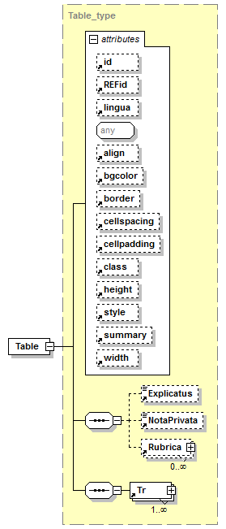
type
Table_type
properties
content | complex
substGrp | Tabula
id | Table_2.1-Folketing
children
Explicatus NotaPrivata Rubrica Tr
attributes
Name | Type | Use | Default | Fixed | annotation
id
REFid
lingua
align
bgcolor
border
cellspacing
cellpadding
class
height
style
summary
width
source
<xsd:element name="Table" type="Table_type" substitutionGroup="Tabula" id="Table_2.1-Folketing"/>

element Tale
diagram
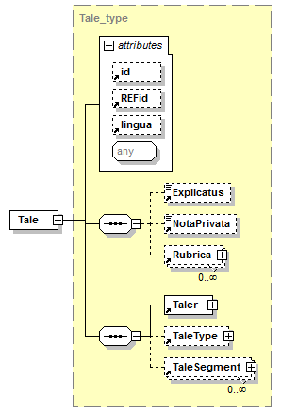
type
Tale_type
properties
content | complex
id | Tale_2.1-Folketing
children
Explicatus NotaPrivata Rubrica Taler TaleType TaleSegment
used by
complexTypes | Aktivitet_type DagsordenUnderpunkt_type
attributes
Name | Type | Use | Default | Fixed | annotation
id
REFid
lingua
source
<xsd:element name="Tale" type="Tale_type" id="Tale_2.1-Folketing"/>

element Taler
diagram
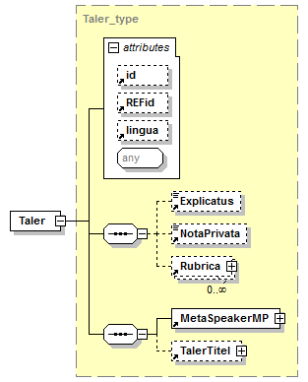
type
Taler_type
properties
content | complex
id | Taler_2.1-Folketing
children
Explicatus NotaPrivata Rubrica MetaSpeakerMP TalerTitel
used by
complexType | Tale_type
attributes
Name | Type | Use | Default | Fixed | annotation
id
REFid
lingua
source
<xsd:element name="Taler" type="Taler_type" id="Taler_2.1-Folketing"/>

element TalerTitel
diagram
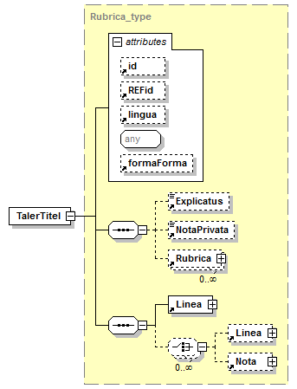
type
Rubrica_type
properties
content | complex
id | TalerTitel_2.1-Folketing
children
Explicatus NotaPrivata Rubrica Linea Nota
used by
complexType | Taler_type
attributes
Name | Type | Use | Default | Fixed | annotation
id
REFid
lingua
formaForma
source
<xsd:element name="TalerTitel" type="Rubrica_type" id="TalerTitel_2.1-Folketing"/>

element TaleSegment
diagram
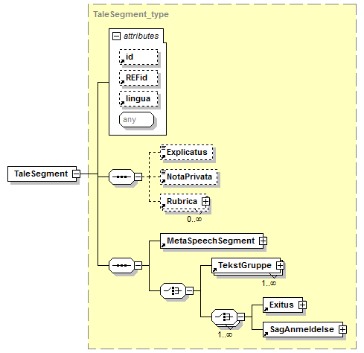
type
TaleSegment_type
properties
content | complex
id | TaleSegment_2.1-Folketing
children
Explicatus NotaPrivata Rubrica MetaSpeechSegment TekstGruppe Exitus SagAnmeldelse
used by
complexType | Tale_type
attributes
Name | Type | Use | Default | Fixed | annotation
id
REFid
lingua
source
<xsd:element name="TaleSegment" type="TaleSegment_type" id="TaleSegment_2.1-Folketing"/>

element TaleType
diagram
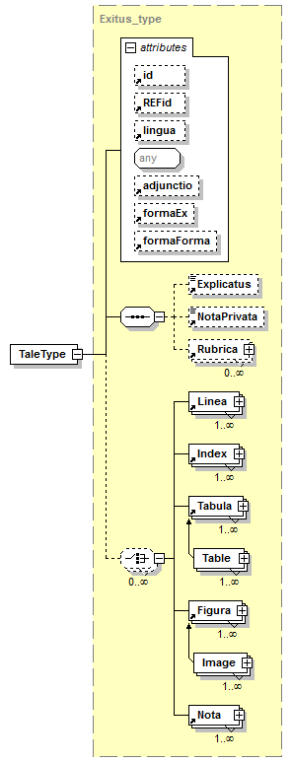
type
Exitus_type
properties
content | complex
id | TaleType_2.1-Folketing
children
Explicatus NotaPrivata Rubrica Linea Index Tabula Figura Nota
used by
complexType | Tale_type
attributes
Name | Type | Use | Default | Fixed | annotation
id
REFid
lingua
adjunctio
formaEx
formaForma
source
<xsd:element name="TaleType" type="Exitus_type" id="TaleType_2.1-Folketing"/>

element Td
diagram
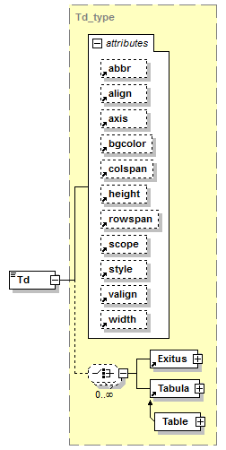
type
Td_type
properties
content | complex
mixed | true
id | Td_2.1-Folketing
children
Exitus Tabula
used by
complexType | Tr_type
attributes
Name | Type | Use | Default | Fixed | annotation
abbr
align
axis
bgcolor
colspan |  |  | 1
height
rowspan |  |  | 1
scope
style
valign
width
source
<xsd:element name="Td" type="Td_type" id="Td_2.1-Folketing"/>

element TekstGruppe
diagram
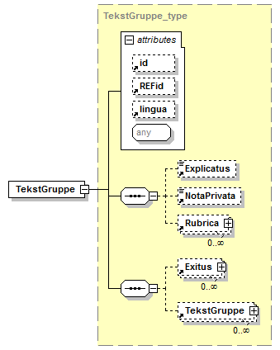
type
TekstGruppe_type
properties
content | complex
id | TekstGruppe_2.0-Folketing
children
Explicatus NotaPrivata Rubrica Exitus TekstGruppe
used by
complexTypes | TaleSegment_type TekstGruppe_type
attributes
Name | Type | Use | Default | Fixed | annotation
id
REFid
lingua
source
<xsd:element name="TekstGruppe" type="TekstGruppe_type" id="TekstGruppe_2.0-Folketing"/>

element Th
diagram
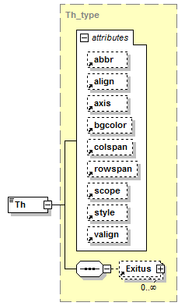
type
Th_type
properties
content | complex
mixed | true
id | Th_2.1-Folketing
children
Exitus
used by
complexType | Tr_type
attributes
Name | Type | Use | Default | Fixed | annotation
abbr
align
axis
bgcolor
colspan |  |  | 1
rowspan |  |  | 1
scope
style
valign
source
<xsd:element name="Th" type="Th_type" id="Th_2.1-Folketing"/>

element Titel
diagram
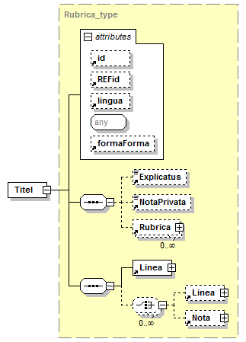
type
Rubrica_type
properties
content | complex
id | Titel_2.1-Folketing
children
Explicatus NotaPrivata Rubrica Linea Nota
used by
complexType | TitelGruppe_type
attributes
Name | Type | Use | Default | Fixed | annotation
id
REFid
lingua
formaForma
source
<xsd:element name="Titel" type="Rubrica_type" id="Titel_2.1-Folketing"/>

element TitelGruppe
diagram
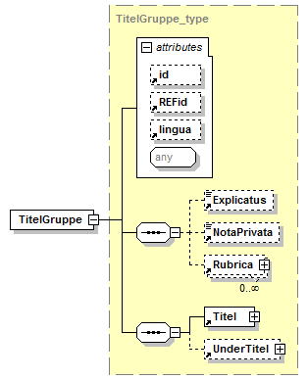
type
TitelGruppe_type
properties
content | complex
id | TitelGruppe_2.1-Folketing
children
Explicatus NotaPrivata Rubrica Titel UnderTitel
used by
complexType | Dokument_type
attributes
Name | Type | Use | Default | Fixed | annotation
id
REFid
lingua
source
<xsd:element name="TitelGruppe" type="TitelGruppe_type" id="TitelGruppe_2.1-Folketing"/>

element Tr
diagram
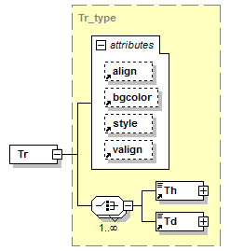
type
Tr_type
properties
content | complex
id | Tr_2.1-Folketing
children
Th Td
used by
complexType | Table_type
attributes
Name | Type | Use | Default | Fixed | annotation
align
bgcolor
style
valign
source
<xsd:element name="Tr" type="Tr_type" id="Tr_2.1-Folketing"/>

element UnderTitel
diagram
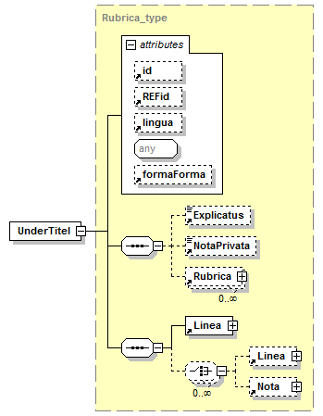
type
Rubrica_type
properties
content | complex
id | UnderTitel_2.1-Folketing
children
Explicatus NotaPrivata Rubrica Linea Nota
used by
complexType | TitelGruppe_type
attributes
Name | Type | Use | Default | Fixed | annotation
id
REFid
lingua
formaForma
source
<xsd:element name="UnderTitel" type="Rubrica_type" id="UnderTitel_2.1-Folketing"/>

complexType Aktivitet_type
diagram
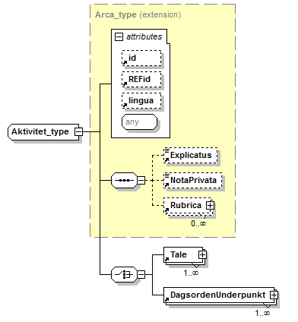
type
extension of Arca_type
properties
base | Arca_type
id | Aktivitet_type_2.1-Folketing
children
Explicatus NotaPrivata Rubrica Tale DagsordenUnderpunkt
used by
element | Aktivitet
attributes
Name | Type | Use | Default | Fixed | annotation
id
REFid
lingua
source
<xsd:complexType name="Aktivitet_type" id="Aktivitet_type_2.1-Folketing">
<xsd:complexContent>
<xsd:extension base="Arca_type">
<xsd:choice>
<xsd:element ref="Tale" maxOccurs="unbounded"/>
<xsd:element ref="DagsordenUnderpunkt" maxOccurs="unbounded"/>
</xsd:choice>
</xsd:extension>
</xsd:complexContent>
</xsd:complexType>

complexType DagsordenPlan_type
diagram
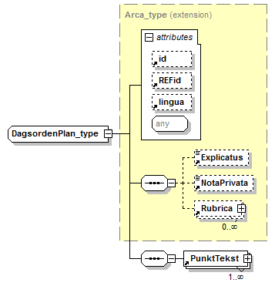
type
extension of Arca_type
properties
base | Arca_type
id | DagsordenPlan_type_2.1-Folketing
children
Explicatus NotaPrivata Rubrica PunktTekst
used by
element | DagsordenPlan
attributes
Name | Type | Use | Default | Fixed | annotation
id
REFid
lingua
source
<xsd:complexType name="DagsordenPlan_type" id="DagsordenPlan_type_2.1-Folketing">
<xsd:complexContent>
<xsd:extension base="Arca_type">
<xsd:sequence>
<xsd:element ref="PunktTekst" maxOccurs="unbounded"/>
</xsd:sequence>
</xsd:extension>
</xsd:complexContent>
</xsd:complexType>

complexType DagsordenPunkt_type
diagram
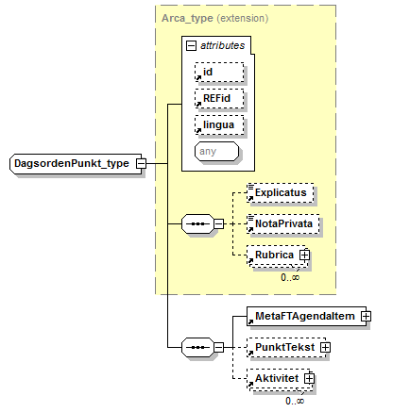
type
extension of Arca_type
properties
base | Arca_type
id | DagsordenPunkt_type_2.1-Folketing
children
Explicatus NotaPrivata Rubrica MetaFTAgendaItem PunktTekst Aktivitet
used by
element | DagsordenPunkt
attributes
Name | Type | Use | Default | Fixed | annotation
id
REFid
lingua
source
<xsd:complexType name="DagsordenPunkt_type" id="DagsordenPunkt_type_2.1-Folketing">
<xsd:complexContent>
<xsd:extension base="Arca_type">
<xsd:sequence>
<xsd:element ref="MetaFTAgendaItem"/>
<xsd:element ref="PunktTekst" minOccurs="0"/>
<xsd:element ref="Aktivitet" minOccurs="0" maxOccurs="unbounded"/>
</xsd:sequence>
</xsd:extension>
</xsd:complexContent>
</xsd:complexType>

complexType DagsordenUnderpunkt_type
diagram
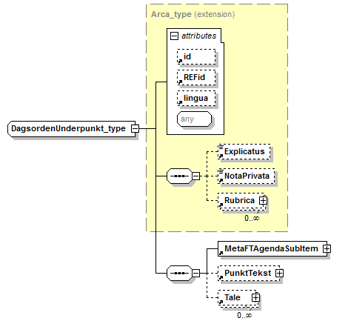
type
extension of Arca_type
properties
base | Arca_type
id | DagsordenUnderpunkt_type_2.1-Folketing
children
Explicatus NotaPrivata Rubrica MetaFTAgendaSubItem PunktTekst Tale
used by
element | DagsordenUnderpunkt
attributes
Name | Type | Use | Default | Fixed | annotation
id
REFid
lingua
source
<xsd:complexType name="DagsordenUnderpunkt_type" id="DagsordenUnderpunkt_type_2.1-Folketing">
<xsd:complexContent>
<xsd:extension base="Arca_type">
<xsd:sequence>
<xsd:element ref="MetaFTAgendaSubItem"/>
<xsd:element ref="PunktTekst" minOccurs="0"/>
<xsd:element ref="Tale" minOccurs="0" maxOccurs="unbounded"/>
</xsd:sequence>
</xsd:extension>
</xsd:complexContent>
</xsd:complexType>

complexType Image_type
diagram
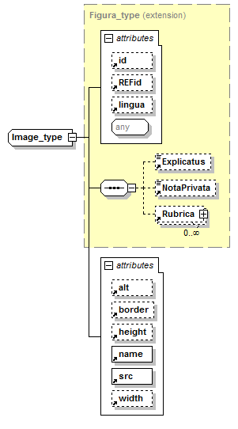
type
extension of Figura_type
properties
base | Figura_type
id | Image_type_2.0-Folketing
children
Explicatus NotaPrivata Rubrica
used by
element | Image
attributes
Name | Type | Use | Default | Fixed | annotation
id
REFid
lingua
alt
border
height
name |  | required
src |  | required
width
source
<xsd:complexType name="Image_type" id="Image_type_2.0-Folketing">
<xsd:complexContent>
<xsd:extension base="Figura_type">
<xsd:attribute ref="alt"/>
<xsd:attribute ref="border"/>
<xsd:attribute ref="height"/>
<xsd:attribute ref="name" use="required"/>
<xsd:attribute ref="src" use="required"/>
<xsd:attribute ref="width"/>
</xsd:extension>
</xsd:complexContent>
</xsd:complexType>

complexType PreTekst_type
diagram
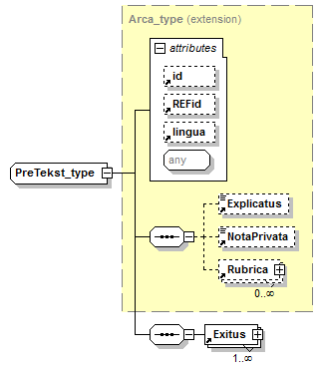
type
extension of Arca_type
properties
base | Arca_type
id | PreTekst_type_2.1-Folketing
children
Explicatus NotaPrivata Rubrica Exitus
used by
element | PreTekst
attributes
Name | Type | Use | Default | Fixed | annotation
id
REFid
lingua
source
<xsd:complexType name="PreTekst_type" id="PreTekst_type_2.1-Folketing">
<xsd:complexContent>
<xsd:extension base="Arca_type">
<xsd:sequence>
<xsd:element ref="Exitus" maxOccurs="unbounded"/>
</xsd:sequence>
</xsd:extension>
</xsd:complexContent>
</xsd:complexType>

complexType PunktTekst_type
diagram
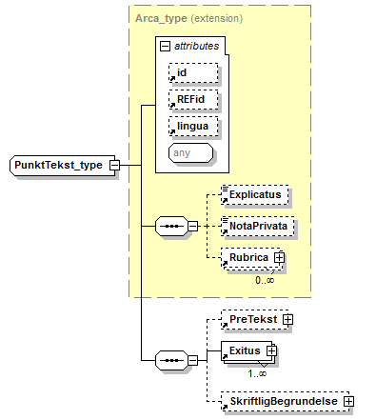
type
extension of Arca_type
properties
base | Arca_type
id | PunktTekst_type_2.1-Folketing
children
Explicatus NotaPrivata Rubrica PreTekst Exitus SkriftligBegrundelse
used by
element | PunktTekst
attributes
Name | Type | Use | Default | Fixed | annotation
id
REFid
lingua
source
<xsd:complexType name="PunktTekst_type" id="PunktTekst_type_2.1-Folketing">
<xsd:complexContent>
<xsd:extension base="Arca_type">
<xsd:sequence>
<xsd:element ref="PreTekst" minOccurs="0"/>
<xsd:element ref="Exitus" maxOccurs="unbounded"/>
<xsd:element ref="SkriftligBegrundelse" minOccurs="0"/>
</xsd:sequence>
</xsd:extension>
</xsd:complexContent>
</xsd:complexType>

complexType SagAnmeldelse_type
diagram
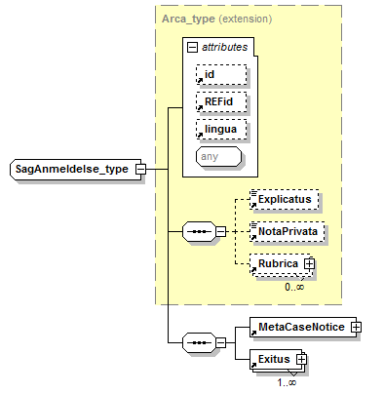
type
extension of Arca_type
properties
base | Arca_type
id | SagAnmeldelse_type_2.1-Folketing
children
Explicatus NotaPrivata Rubrica MetaCaseNotice Exitus
used by
element | SagAnmeldelse
attributes
Name | Type | Use | Default | Fixed | annotation
id
REFid
lingua
source
<xsd:complexType name="SagAnmeldelse_type" id="SagAnmeldelse_type_2.1-Folketing">
<xsd:complexContent>
<xsd:extension base="Arca_type">
<xsd:sequence>
<xsd:element ref="MetaCaseNotice"/>
<xsd:element ref="Exitus" maxOccurs="unbounded"/>
</xsd:sequence>
</xsd:extension>
</xsd:complexContent>
</xsd:complexType>

complexType SkriftligBegrundelse_type
diagram
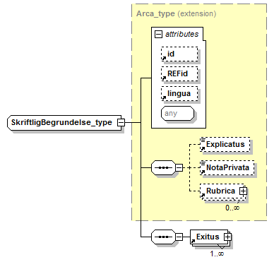
type
extension of Arca_type
properties
base | Arca_type
id | SkriftligBegrundelse_type_2.1-Folketing
children
Explicatus NotaPrivata Rubrica Exitus
used by
element | SkriftligBegrundelse
attributes
Name | Type | Use | Default | Fixed | annotation
id
REFid
lingua
source
<xsd:complexType name="SkriftligBegrundelse_type" id="SkriftligBegrundelse_type_2.1-Folketing">
<xsd:complexContent>
<xsd:extension base="Arca_type">
<xsd:sequence>
<xsd:element ref="Exitus" maxOccurs="unbounded"/>
</xsd:sequence>
</xsd:extension>
</xsd:complexContent>
</xsd:complexType>

complexType Table_type
diagram
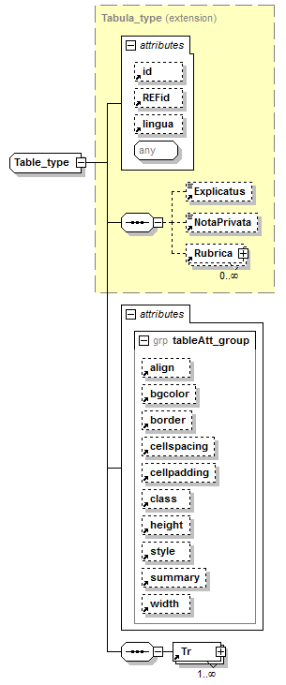
type
extension of Tabula_type
properties
base | Tabula_type
id | Table_type_2.1-Folketing
children
Explicatus NotaPrivata Rubrica Tr
used by
element | Table
attributes
Name | Type | Use | Default | Fixed | annotation
id
REFid
lingua
align
bgcolor
border
cellspacing
cellpadding
class
height
style
summary
width
source
<xsd:complexType name="Table_type" id="Table_type_2.1-Folketing">
<xsd:complexContent>
<xsd:extension base="Tabula_type">
<xsd:sequence>
<xsd:element ref="Tr" maxOccurs="unbounded"/>
</xsd:sequence>
<xsd:attributeGroup ref="tableAtt_group"/>
</xsd:extension>
</xsd:complexContent>
</xsd:complexType>

complexType Tale_type
diagram
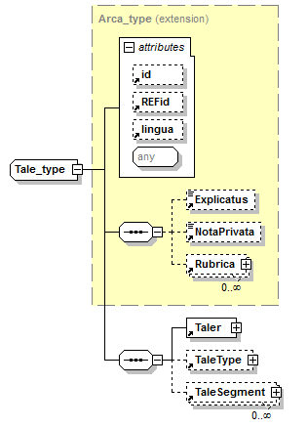
type
extension of Arca_type
properties
base | Arca_type
id | Tale_type_2.1-Folketing
children
Explicatus NotaPrivata Rubrica Taler TaleType TaleSegment
used by
element | Tale
attributes
Name | Type | Use | Default | Fixed | annotation
id
REFid
lingua
source
<xsd:complexType name="Tale_type" id="Tale_type_2.1-Folketing">
<xsd:complexContent>
<xsd:extension base="Arca_type">
<xsd:sequence>
<xsd:element ref="Taler"/>
<xsd:element ref="TaleType" minOccurs="0"/>
<xsd:element ref="TaleSegment" minOccurs="0" maxOccurs="unbounded"/>
</xsd:sequence>
</xsd:extension>
</xsd:complexContent>
</xsd:complexType>

complexType Taler_type
diagram
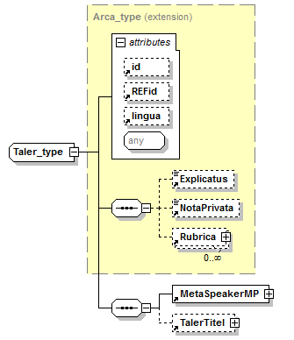
type
extension of Arca_type
properties
base | Arca_type
id | Taler_type_2.1-Folketing
children
Explicatus NotaPrivata Rubrica MetaSpeakerMP TalerTitel
used by
element | Taler
attributes
Name | Type | Use | Default | Fixed | annotation
id
REFid
lingua
source
<xsd:complexType name="Taler_type" id="Taler_type_2.1-Folketing">
<xsd:complexContent>
<xsd:extension base="Arca_type">
<xsd:sequence>
<xsd:element ref="MetaSpeakerMP"/>
<xsd:element ref="TalerTitel" minOccurs="0"/>
</xsd:sequence>
</xsd:extension>
</xsd:complexContent>
</xsd:complexType>

complexType TaleSegment_type
diagram
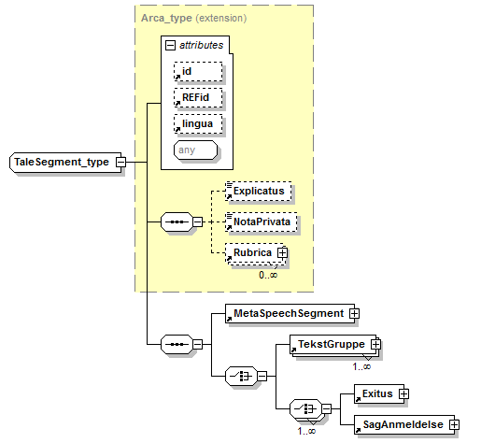
type
extension of Arca_type
properties
base | Arca_type
id | TaleSegment_type_2.1-Folketing
children
Explicatus NotaPrivata Rubrica MetaSpeechSegment TekstGruppe Exitus SagAnmeldelse
used by
element | TaleSegment
attributes
Name | Type | Use | Default | Fixed | annotation
id
REFid
lingua
source
<xsd:complexType name="TaleSegment_type" id="TaleSegment_type_2.1-Folketing">
<xsd:complexContent>
<xsd:extension base="Arca_type">
<xsd:sequence>
<xsd:element ref="MetaSpeechSegment"/>
<xsd:choice>
<xsd:element ref="TekstGruppe" maxOccurs="unbounded"/>
<xsd:choice maxOccurs="unbounded">
<xsd:element ref="Exitus"/>
<xsd:element ref="SagAnmeldelse"/>
</xsd:choice>
</xsd:choice>
</xsd:sequence>
</xsd:extension>
</xsd:complexContent>
</xsd:complexType>

complexType Td_type
diagram
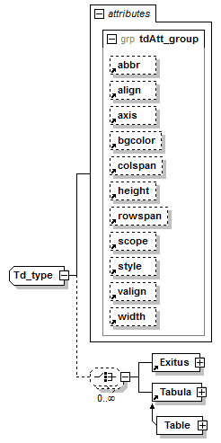
properties
mixed | true
id | Td_type_2.1-Folketing
children
Exitus Tabula
used by
element | Td
attributes
Name | Type | Use | Default | Fixed | annotation
abbr
align
axis
bgcolor
colspan |  |  | 1
height
rowspan |  |  | 1
scope
style
valign
width
source
<xsd:complexType name="Td_type" id="Td_type_2.1-Folketing" mixed="true">
<xsd:choice minOccurs="0" maxOccurs="unbounded">
<xsd:element ref="Exitus"/>
<xsd:element ref="Tabula"/>
</xsd:choice>
<xsd:attributeGroup ref="tdAtt_group"/>
</xsd:complexType>

complexType TekstGruppe_type
diagram
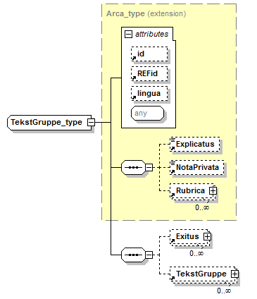
type
extension of Arca_type
properties
base | Arca_type
id | TekstGruppe_type_2.1-Folketing
children
Explicatus NotaPrivata Rubrica Exitus TekstGruppe
used by
element | TekstGruppe
attributes
Name | Type | Use | Default | Fixed | annotation
id
REFid
lingua
source
<xsd:complexType name="TekstGruppe_type" id="TekstGruppe_type_2.1-Folketing">
<xsd:complexContent>
<xsd:extension base="Arca_type">
<xsd:sequence>
<xsd:element ref="Exitus" minOccurs="0" maxOccurs="unbounded"/>
<xsd:element ref="TekstGruppe" minOccurs="0" maxOccurs="unbounded"/>
</xsd:sequence>
</xsd:extension>
</xsd:complexContent>
</xsd:complexType>

complexType Th_type
diagram
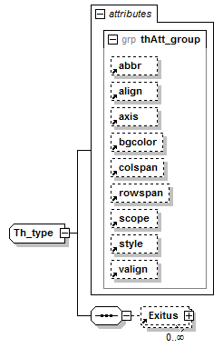
properties
mixed | true
id | Th_type_2.1-Folketing
children
Exitus
used by
element | Th
attributes
Name | Type | Use | Default | Fixed | annotation
abbr
align
axis
bgcolor
colspan |  |  | 1
rowspan |  |  | 1
scope
style
valign
source
<xsd:complexType name="Th_type" id="Th_type_2.1-Folketing" mixed="true">
<xsd:sequence>
<xsd:element ref="Exitus" minOccurs="0" maxOccurs="unbounded"/>
</xsd:sequence>
<xsd:attributeGroup ref="thAtt_group"/>
</xsd:complexType>

complexType TitelGruppe_type
diagram
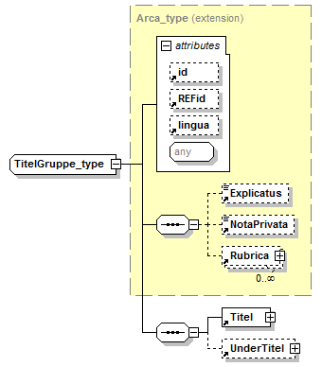
type
extension of Arca_type
properties
base | Arca_type
id | TitelGruppe_type_2.1-Folketing
children
Explicatus NotaPrivata Rubrica Titel UnderTitel
used by
element | TitelGruppe
attributes
Name | Type | Use | Default | Fixed | annotation
id
REFid
lingua
source
<xsd:complexType name="TitelGruppe_type" id="TitelGruppe_type_2.1-Folketing">
<xsd:complexContent>
<xsd:extension base="Arca_type">
<xsd:sequence>
<xsd:element ref="Titel"/>
<xsd:element ref="UnderTitel" minOccurs="0"/>
</xsd:sequence>
</xsd:extension>
</xsd:complexContent>
</xsd:complexType>

complexType Tr_type
diagram
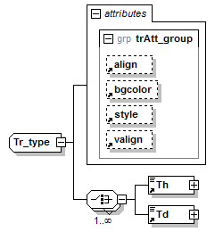
properties
id | Tr_type_2.1-Folketing
children
Th Td
used by
element | Tr
attributes
Name | Type | Use | Default | Fixed | annotation
align
bgcolor
style
valign
source
<xsd:complexType name="Tr_type" id="Tr_type_2.1-Folketing">
<xsd:choice maxOccurs="unbounded">
<xsd:element ref="Th"/>
<xsd:element ref="Td"/>
</xsd:choice>
<xsd:attributeGroup ref="trAtt_group"/>
</xsd:complexType>

attributeGroup tableAtt_group
properties
id | tableAtt_group_2.1-Folketing
used by
complexType | Table_type
attributes
Name | Type | Use | Default | Fixed | annotation
align
bgcolor
border
cellspacing
cellpadding
class
height
style
summary
width
source
<xsd:attributeGroup name="tableAtt_group" id="tableAtt_group_2.1-Folketing">
<xsd:attribute ref="align"/>
<xsd:attribute ref="bgcolor"/>
<xsd:attribute ref="border"/>
<xsd:attribute ref="cellspacing"/>
<xsd:attribute ref="cellpadding"/>
<xsd:attribute ref="class"/>
<xsd:attribute ref="height"/>
<xsd:attribute ref="style"/>
<xsd:attribute ref="summary"/>
<xsd:attribute ref="width"/>
</xsd:attributeGroup>

attributeGroup tdAtt_group
properties
id | tdAtt_group_2.1-Folketing
used by
complexType | Td_type
attributes
Name | Type | Use | Default | Fixed | annotation
abbr
align
axis
bgcolor
colspan |  |  | 1
height
rowspan |  |  | 1
scope
style
valign
width
source
<xsd:attributeGroup name="tdAtt_group" id="tdAtt_group_2.1-Folketing">
<xsd:attribute ref="abbr"/>
<xsd:attribute ref="align"/>
<xsd:attribute ref="axis"/>
<xsd:attribute ref="bgcolor"/>
<xsd:attribute ref="colspan" default="1"/>
<xsd:attribute ref="height"/>
<xsd:attribute ref="rowspan" default="1"/>
<xsd:attribute ref="scope"/>
<xsd:attribute ref="style"/>
<xsd:attribute ref="valign"/>
<xsd:attribute ref="width"/>
</xsd:attributeGroup>

attributeGroup thAtt_group
properties
id | thAtt_group_2.1-Folketing
used by
complexType | Th_type
attributes
Name | Type | Use | Default | Fixed | annotation
abbr
align
axis
bgcolor
colspan |  |  | 1
rowspan |  |  | 1
scope
style
valign
source
<xsd:attributeGroup name="thAtt_group" id="thAtt_group_2.1-Folketing">
<xsd:attribute ref="abbr"/>
<xsd:attribute ref="align"/>
<xsd:attribute ref="axis"/>
<xsd:attribute ref="bgcolor"/>
<xsd:attribute ref="colspan" default="1"/>
<xsd:attribute ref="rowspan" default="1"/>
<xsd:attribute ref="scope"/>
<xsd:attribute ref="style"/>
<xsd:attribute ref="valign"/>
</xsd:attributeGroup>

attributeGroup trAtt_group
properties
id | trAtt_group_2.1-Folketing
used by
complexType | Tr_type
attributes
Name | Type | Use | Default | Fixed | annotation
align
bgcolor
style
valign
source
<xsd:attributeGroup name="trAtt_group" id="trAtt_group_2.1-Folketing">
<xsd:attribute ref="align"/>
<xsd:attribute ref="bgcolor"/>
<xsd:attribute ref="style"/>
<xsd:attribute ref="valign"/>
</xsd:attributeGroup>

attribute adjunctio
type
xsd:anyURI
properties
id | adjunctio-LexDania_2.1
used by
complexTypes | Char_type Exitus_type Linea_type
source
<xsd:attribute name="adjunctio" type="xs:anyURI" id="adjunctio-LexDania_2.1"/>

attribute formaChar
type
restriction of xsd:string
properties
id | formaChar.LexDania_2.1
used by
complexType | Char_type
facets
enumeration | Bold
enumeration | BoldItalic
enumeration | BoldItalicUnderline
enumeration | BoldUnderline
enumeration | Italic
enumeration | ItalicUnderline
enumeration | Subscript
enumeration | Superscript
enumeration | Underline
source
<xsd:attribute name="formaChar" id="formaChar.LexDania_2.1">
<xsd:simpleType>
<xsd:restriction base="xs:string">
<xsd:enumeration value="Bold"/>
<xsd:enumeration value="BoldItalic"/>
<xsd:enumeration value="BoldItalicUnderline"/>
<xsd:enumeration value="BoldUnderline"/>
<xsd:enumeration value="Italic"/>
<xsd:enumeration value="ItalicUnderline"/>
<xsd:enumeration value="Subscript"/>
<xsd:enumeration value="Superscript"/>
<xsd:enumeration value="Underline"/>
</xsd:restriction>
</xsd:simpleType>
</xsd:attribute>

attribute formaEx
type
restriction of xsd:string
properties
id | formaEx.LexDania_2.1
used by
complexType | Exitus_type
facets
enumeration | Align
enumeration | Center
enumeration | Left
enumeration | Right
source
<xsd:attribute name="formaEx" id="formaEx.LexDania_2.1">
<xsd:simpleType>
<xsd:restriction base="xs:string">
<xsd:enumeration value="Align"/>
<xsd:enumeration value="Center"/>
<xsd:enumeration value="Left"/>
<xsd:enumeration value="Right"/>
</xsd:restriction>
</xsd:simpleType>
</xsd:attribute>

attribute formaForma
type
restriction of xsd:string
properties
id | formaForma.LexDania_2.1
used by
complexTypes | Exitus_type Rubrica_type
facets
enumeration | AendretBestemmelse
enumeration | Aendringspunkt
enumeration | Af
enumeration | Af2
enumeration | Afsnitsnummer
enumeration | Afsnitsoverskrift
enumeration | Anmaerkninger
enumeration | BemTil
enumeration | BemTilCI
enumeration | BemTilV
enumeration | BemTilVBf
enumeration | BemTilVI
enumeration | Bilagstekst
enumeration | CParagrafnummer
enumeration | CParagraftekst
enumeration | FolSam
enumeration | FremsaetterUndertitel
enumeration | Henvendelse
enumeration | Hymne
enumeration | IkkeMedlemmer
enumeration | IkraftCentreretParagrafNummer
enumeration | Ikrafttraedelse
enumeration | IndholdHdr
enumeration | IndholdHdr2
enumeration | Indledning
enumeration | Indledning2
enumeration | Indstilling
enumeration | Kapitelnummer
enumeration | Kapiteloverskrift
enumeration | KapiteloverskriftBm
enumeration | Kommentar
enumeration | Litra
enumeration | Litra9
enumeration | lsp6
enumeration | lsp8L
enumeration | Lsp8LL
enumeration | Medlemmer
enumeration | Normal9
enumeration | NormalVenstre
enumeration | NormalLuft
enumeration | NormalInd
enumeration | NormalInd9
enumeration | Nummer
enumeration | Nummer9
enumeration | OverskriftSp
enumeration | Paragraftekst
enumeration | ParaOverskrift
enumeration | ParaOverskriftBm
enumeration | Pind
enumeration | Pind9
enumeration | PreTitel0
enumeration | PreTitel1
enumeration | PreTitel2
enumeration | Resume
enumeration | ResumeTekst
enumeration | SIGN0
enumeration | SkrFrem
enumeration | Slutnotetekst
enumeration | Stk
enumeration | Subtitle
enumeration | TabelFod
enumeration | TabelHoved
enumeration | TabelOverskrift
enumeration | TabelTekst
enumeration | Tabeltekst9
enumeration | TabelTekstHøjre
enumeration | Tekst
enumeration | Standard
enumeration | Tekst0
enumeration | Tekst1
enumeration | Tekst1Sp
enumeration | Tekst2
enumeration | Tekst9
enumeration | Tekstoverskrift
enumeration | TekstoverskriftB
enumeration | TekstoverskriftBm
enumeration | TekstoverskriftVenstre
enumeration | TekstoverskriftVenstreBm
enumeration | TekstoverskriftVenstreN
enumeration | TekstResume
enumeration | TekstV
enumeration | Titel
enumeration | Title
enumeration | Undertitel
enumeration | Skjult
source
<xsd:attribute name="formaForma" id="formaForma.LexDania_2.1">
<xsd:simpleType>
<xsd:restriction base="xs:string">
<xsd:enumeration value="AendretBestemmelse"/>
<xsd:enumeration value="Aendringspunkt"/>
<xsd:enumeration value="Af"/>
<xsd:enumeration value="Af2"/>
<xsd:enumeration value="Afsnitsnummer"/>
<xsd:enumeration value="Afsnitsoverskrift"/>
<xsd:enumeration value="Anmaerkninger"/>
<xsd:enumeration value="BemTil"/>
<xsd:enumeration value="BemTilCI"/>
<xsd:enumeration value="BemTilV"/>
<xsd:enumeration value="BemTilVBf"/>
<xsd:enumeration value="BemTilVI"/>
<xsd:enumeration value="Bilagstekst"/>
<xsd:enumeration value="CParagrafnummer"/>
<xsd:enumeration value="CParagraftekst"/>
<xsd:enumeration value="FolSam"/>
<xsd:enumeration value="FremsaetterUndertitel"/>
<xsd:enumeration value="Henvendelse"/>
<xsd:enumeration value="Hymne"/>
<xsd:enumeration value="IkkeMedlemmer"/>
<xsd:enumeration value="IkraftCentreretParagrafNummer"/>
<xsd:enumeration value="Ikrafttraedelse"/>
<xsd:enumeration value="IndholdHdr"/>
<xsd:enumeration value="IndholdHdr2"/>
<xsd:enumeration value="Indledning"/>
<xsd:enumeration value="Indledning2"/>
<xsd:enumeration value="Indstilling"/>
<xsd:enumeration value="Kapitelnummer"/>
<xsd:enumeration value="Kapiteloverskrift"/>
<xsd:enumeration value="KapiteloverskriftBm"/>
<xsd:enumeration value="Kommentar"/>
<xsd:enumeration value="Litra"/>
<xsd:enumeration value="Litra9"/>
<xsd:enumeration value="lsp6"/>
<xsd:enumeration value="lsp8L"/>
<xsd:enumeration value="Lsp8LL"/>
<xsd:enumeration value="Medlemmer"/>
<xsd:enumeration value="Normal9"/>
<xsd:enumeration value="NormalVenstre"/>
<xsd:enumeration value="NormalLuft"/>
<xsd:enumeration value="NormalInd"/>
<xsd:enumeration value="NormalInd9"/>
<xsd:enumeration value="Nummer"/>
<xsd:enumeration value="Nummer9"/>
<xsd:enumeration value="OverskriftSp"/>
<xsd:enumeration value="Paragraftekst"/>
<xsd:enumeration value="ParaOverskrift"/>
<xsd:enumeration value="ParaOverskriftBm"/>
<xsd:enumeration value="Pind"/>
<xsd:enumeration value="Pind9"/>
<xsd:enumeration value="PreTitel0"/>
<xsd:enumeration value="PreTitel1"/>
<xsd:enumeration value="PreTitel2"/>
<xsd:enumeration value="Resume"/>
<xsd:enumeration value="ResumeTekst"/>
<xsd:enumeration value="SIGN0"/>
<xsd:enumeration value="SkrFrem"/>
<xsd:enumeration value="Slutnotetekst"/>
<xsd:enumeration value="Stk"/>
<xsd:enumeration value="Subtitle"/>
<xsd:enumeration value="TabelFod"/>
<xsd:enumeration value="TabelHoved"/>
<xsd:enumeration value="TabelOverskrift"/>
<xsd:enumeration value="TabelTekst"/>
<xsd:enumeration value="Tabeltekst9"/>
<xsd:enumeration value="TabelTekstHøjre"/>
<xsd:enumeration value="Tekst"/>
<xsd:enumeration value="Standard"/>
<xsd:enumeration value="Tekst0"/>
<xsd:enumeration value="Tekst1"/>
<xsd:enumeration value="Tekst1Sp"/>
<xsd:enumeration value="Tekst2"/>
<xsd:enumeration value="Tekst9"/>
<xsd:enumeration value="Tekstoverskrift"/>
<xsd:enumeration value="TekstoverskriftB"/>
<xsd:enumeration value="TekstoverskriftBm"/>
<xsd:enumeration value="TekstoverskriftVenstre"/>
<xsd:enumeration value="TekstoverskriftVenstreBm"/>
<xsd:enumeration value="TekstoverskriftVenstreN"/>
<xsd:enumeration value="TekstResume"/>
<xsd:enumeration value="TekstV"/>
<xsd:enumeration value="Titel"/>
<xsd:enumeration value="Title"/>
<xsd:enumeration value="Undertitel"/>
<xsd:enumeration value="Skjult"/>
</xsd:restriction>
</xsd:simpleType>
</xsd:attribute>

attribute formaInd
type
restriction of xsd:string
properties
id | formaInd.LexDania_2.1
used by
complexType | Indentatio_type
facets
enumeration | Nummer
enumeration | Litra
enumeration | Pind
enumeration | Fri
source
<xsd:attribute name="formaInd" id="formaInd.LexDania_2.1">
<xsd:simpleType>
<xsd:restriction base="xs:string">
<xsd:enumeration value="Nummer"/>
<xsd:enumeration value="Litra"/>
<xsd:enumeration value="Pind"/>
<xsd:enumeration value="Fri"/>
</xsd:restriction>
</xsd:simpleType>
</xsd:attribute>

attribute formaNo
type
restriction of xsd:string
properties
id | formaNo.LexDania_2.1
used by
complexType | Nota_type
facets
enumeration | EU
enumeration | Folketinget
enumeration | Tabel
source
<xsd:attribute name="formaNo" id="formaNo.LexDania_2.1">
<xsd:simpleType>
<xsd:restriction base="xs:string">
<xsd:enumeration value="EU"/>
<xsd:enumeration value="Folketinget"/>
<xsd:enumeration value="Tabel"/>
</xsd:restriction>
</xsd:simpleType>
</xsd:attribute>

attribute id
type
xsd:ID
properties
id | id.LexDania_2.1
used by
element | FTCase
complexTypes | Arca_type Char_type
source
<xsd:attribute name="id" type="xs:ID" id="id.LexDania_2.1"/>

attribute lingua
type
xsd:string
properties
id | lingua.LexDania_2.1
used by
complexType | Arca_type
source
<xsd:attribute name="lingua" type="xs:string" id="lingua.LexDania_2.1"/>

attribute REFid
type
xsd:anyURI
properties
id | REFid-LexDania_2.1
used by
elements | FTCaseNumber FTCaseStage FTCaseType
complexTypes | Arca_type Char_type
source
<xsd:attribute name="REFid" type="xs:anyURI" id="REFid-LexDania_2.1"/>

attribute signiChar
type
restriction of xsd:string
properties
id | signiChar.LexDania_2.1
used by
complexType | Char_type
facets
enumeration | AendringURN
source
<xsd:attribute name="signiChar" id="signiChar.LexDania_2.1">
<xsd:simpleType>
<xsd:restriction base="xs:string">
<xsd:enumeration value="AendringURN"/>
</xsd:restriction>
</xsd:simpleType>
</xsd:attribute>

element Arca
diagram
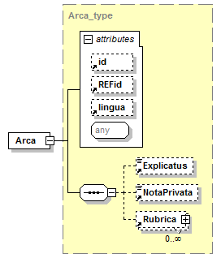
type
Arca_type
properties
content | complex
id | Arca.Kernel.LexDania_2.1
children
Explicatus NotaPrivata Rubrica
attributes
Name | Type | Use | Default | Fixed | annotation
id
REFid
lingua
source
<xsd:element name="Arca" type="Arca_type" id="Arca.Kernel.LexDania_2.1"/>

element Char
diagram
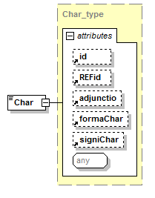
type
Char_type
properties
content | complex
id | Char.LexDania_2.1
used by
complexType | Linea_type
attributes
Name | Type | Use | Default | Fixed | annotation
id
REFid
adjunctio
formaChar
signiChar
source
<xsd:element name="Char" type="Char_type" id="Char.LexDania_2.1"/>

element Exitus
diagram
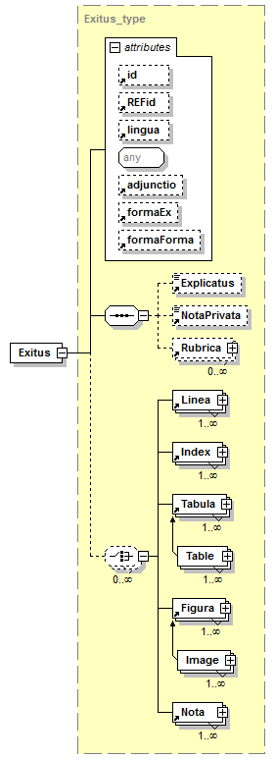
type
Exitus_type
properties
content | complex
id | Exitus.LexDania_2.1
children
Explicatus NotaPrivata Rubrica Linea Index Tabula Figura Nota
used by
complexTypes | Indentatio_type Nota_type PreTekst_type PunktTekst_type SagAnmeldelse_type SkriftligBegrundelse_type TaleSegment_type Td_type TekstGruppe_type Th_type
attributes
Name | Type | Use | Default | Fixed | annotation
id
REFid
lingua
adjunctio
formaEx
formaForma
source
<xsd:element name="Exitus" type="Exitus_type" id="Exitus.LexDania_2.1"/>

element Explicatus
diagram
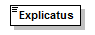
type
xsd:string
properties
content | simple
id | Explicatus-LexDania_2.1
used by
complexType | Arca_type
source
<xsd:element name="Explicatus" type="xs:string" id="Explicatus-LexDania_2.1"/>

element Figura
diagram
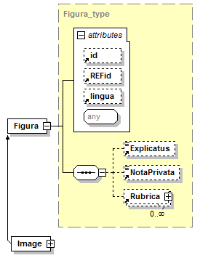
type
Figura_type
properties
content | complex
id | Figura.LexDania_2.1
children
Explicatus NotaPrivata Rubrica
used by
complexType | Exitus_type
attributes
Name | Type | Use | Default | Fixed | annotation
id
REFid
lingua
source
<xsd:element name="Figura" type="Figura_type" id="Figura.LexDania_2.1"/>

element Indentatio
diagram
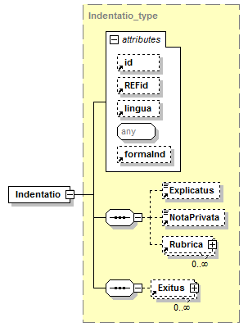
type
Indentatio_type
properties
content | complex
id | Indentatio.LexDania_2.1
children
Explicatus NotaPrivata Rubrica Exitus
used by
complexType | Index_type
attributes
Name | Type | Use | Default | Fixed | annotation
id
REFid
lingua
formaInd
source
<xsd:element name="Indentatio" type="Indentatio_type" id="Indentatio.LexDania_2.1"/>

element Index
diagram
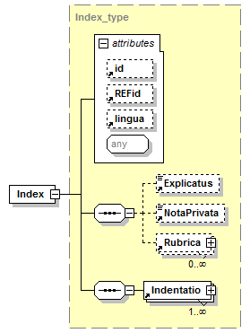
type
Index_type
properties
content | complex
id | Index.LexDania_2.1
children
Explicatus NotaPrivata Rubrica Indentatio
used by
complexType | Exitus_type
attributes
Name | Type | Use | Default | Fixed | annotation
id
REFid
lingua
source
<xsd:element name="Index" type="Index_type" id="Index.LexDania_2.1"/>

element Linea
diagram
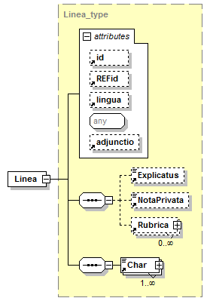
type
Linea_type
properties
content | complex
id | Linea.LexDania_2.1
children
Explicatus NotaPrivata Rubrica Char
used by
complexTypes | Exitus_type Rubrica_type Rubrica_type
attributes
Name | Type | Use | Default | Fixed | annotation
id
REFid
lingua
adjunctio
source
<xsd:element name="Linea" type="Linea_type" id="Linea.LexDania_2.1"/>

element Nota
diagram
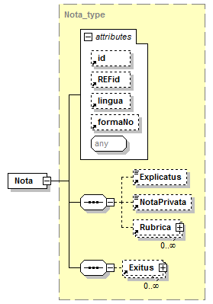
type
Nota_type
properties
content | complex
id | Nota-LexDania_2.1
children
Explicatus NotaPrivata Rubrica Exitus
used by
complexTypes | Exitus_type Rubrica_type
attributes
Name | Type | Use | Default | Fixed | annotation
id
REFid
lingua
formaNo
source
<xsd:element name="Nota" type="Nota_type" id="Nota-LexDania_2.1"/>

element NotaPrivata
diagram

type
xsd:string
properties
content | simple
used by
complexType | Arca_type
source
<xsd:element name="NotaPrivata" type="xs:string"/>

element Rubrica
diagram
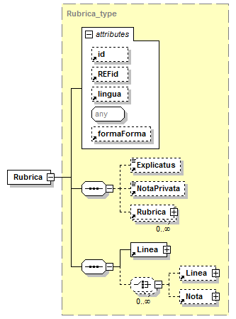
type
Rubrica_type
properties
content | complex
id | Rubrica-LexDania_2.1
children
Explicatus NotaPrivata Rubrica Linea Nota
used by
complexType | Arca_type
attributes
Name | Type | Use | Default | Fixed | annotation
id
REFid
lingua
formaForma
source
<xsd:element name="Rubrica" type="Rubrica_type" id="Rubrica-LexDania_2.1"/>

element Tabula
diagram
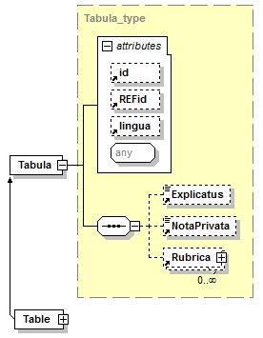
type
Tabula_type
properties
content | complex
id | Tabula.LexDania_2.1
children
Explicatus NotaPrivata Rubrica
used by
complexTypes | Exitus_type Td_type
attributes
Name | Type | Use | Default | Fixed | annotation
id
REFid
lingua
source
<xsd:element name="Tabula" type="Tabula_type" id="Tabula.LexDania_2.1"/>

complexType Arca_type
diagram
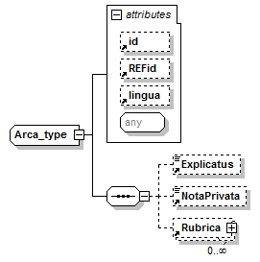
properties
id | Arca_type-LexDania_2.1
children
Explicatus NotaPrivata Rubrica
used by
element | Arca
complexTypes | Aktivitet_type DagsordenPlan_type DagsordenPunkt_type DagsordenUnderpunkt_type Dokument_type Exitus_type Figura_type Indentatio_type Index_type Linea_type MetaCaseNotice_type MetaFTAgendaItem_type MetaFTAgendaSubItem_type MetaMeeting_type MetaSpeakerMP_type MetaSpeechSegment_type Nota_type PreTekst_type PunktTekst_type Rubrica_type SagAnmeldelse_type SkriftligBegrundelse_type Tabula_type Tale_type Taler_type TaleSegment_type TekstGruppe_type TitelGruppe_type
attributes
Name | Type | Use | Default | Fixed | annotation
id
REFid
lingua
source
<xsd:complexType name="Arca_type" id="Arca_type-LexDania_2.1">
<xsd:sequence>
<xsd:element ref="Explicatus" minOccurs="0"/>
<xsd:element ref="NotaPrivata" minOccurs="0"/>
<xsd:element ref="Rubrica" minOccurs="0" maxOccurs="unbounded"/>
</xsd:sequence>
<xsd:attribute ref="id"/>
<xsd:attribute ref="REFid"/>
<xsd:attribute ref="lingua"/>
<xsd:anyAttribute/>
</xsd:complexType>

complexType Char_type
diagram
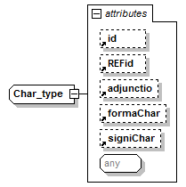
type
extension of xsd:string
properties
base | xs:string
id | Char_type-LexDania_2.1
used by
element | Char
attributes
Name | Type | Use | Default | Fixed | annotation
id
REFid
adjunctio
formaChar
signiChar
source
<xsd:complexType name="Char_type" id="Char_type-LexDania_2.1">
<xsd:simpleContent>
<xsd:extension base="xs:string">
<xsd:attribute ref="id"/>
<xsd:attribute ref="REFid"/>
<xsd:attribute ref="adjunctio"/>
<xsd:attribute ref="formaChar"/>
<xsd:attribute ref="signiChar"/>
<xsd:anyAttribute/>
</xsd:extension>
</xsd:simpleContent>
</xsd:complexType>

complexType Exitus_type
diagram
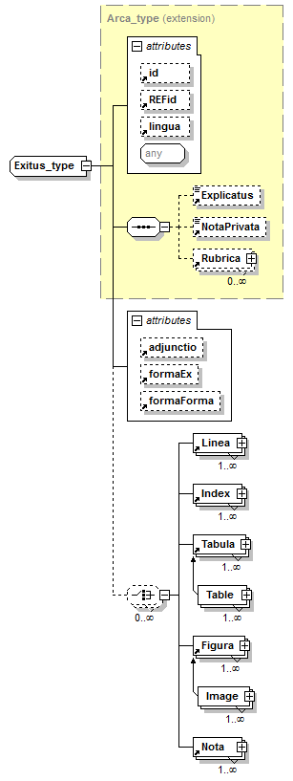
type
extension of Arca_type
properties
base | Arca_type
id | Exitus_type-LexDania_2.1
children
Explicatus NotaPrivata Rubrica Linea Index Tabula Figura Nota
used by
elements | Exitus TaleType
attributes
Name | Type | Use | Default | Fixed | annotation
id
REFid
lingua
adjunctio
formaEx
formaForma
source
<xsd:complexType name="Exitus_type" id="Exitus_type-LexDania_2.1">
<xsd:complexContent>
<xsd:extension base="Arca_type">
<xsd:choice minOccurs="0" maxOccurs="unbounded">
<xsd:element ref="Linea" maxOccurs="unbounded"/>
<xsd:element ref="Index" maxOccurs="unbounded"/>
<xsd:element ref="Tabula" maxOccurs="unbounded"/>
<xsd:element ref="Figura" maxOccurs="unbounded"/>
<xsd:element ref="Nota" maxOccurs="unbounded"/>
</xsd:choice>
<xsd:attribute ref="adjunctio"/>
<xsd:attribute ref="formaEx"/>
<xsd:attribute ref="formaForma"/>
</xsd:extension>
</xsd:complexContent>
</xsd:complexType>

complexType Figura_type
diagram
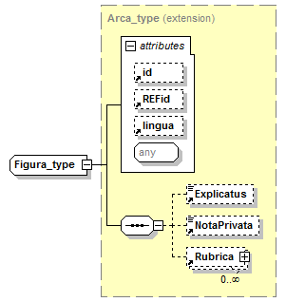
type
extension of Arca_type
properties
base | Arca_type
id | Figura_type-LexDania_2.1
children
Explicatus NotaPrivata Rubrica
used by
element | Figura
complexType | Image_type
attributes
Name | Type | Use | Default | Fixed | annotation
id
REFid
lingua
source
<xsd:complexType name="Figura_type" id="Figura_type-LexDania_2.1">
<xsd:complexContent>
<xsd:extension base="Arca_type"/>
</xsd:complexContent>
</xsd:complexType>

complexType Indentatio_type
diagram
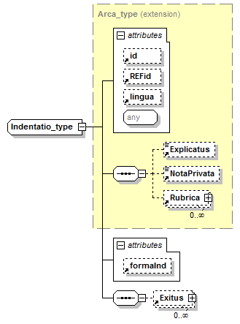
type
extension of Arca_type
properties
base | Arca_type
id | Indentatio_type-LexDania_2.1
children
Explicatus NotaPrivata Rubrica Exitus
used by
element | Indentatio
attributes
Name | Type | Use | Default | Fixed | annotation
id
REFid
lingua
formaInd
source
<xsd:complexType name="Indentatio_type" id="Indentatio_type-LexDania_2.1">
<xsd:complexContent>
<xsd:extension base="Arca_type">
<xsd:sequence>
<xsd:element ref="Exitus" minOccurs="0" maxOccurs="unbounded"/>
</xsd:sequence>
<xsd:attribute ref="formaInd"/>
</xsd:extension>
</xsd:complexContent>
</xsd:complexType>

complexType Index_type
diagram
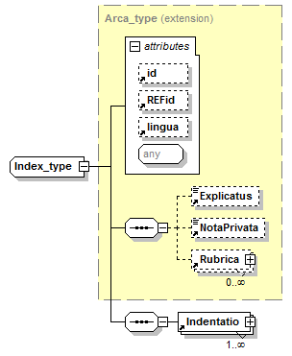
type
extension of Arca_type
properties
base | Arca_type
id | Index_type-LexDania_2.1
children
Explicatus NotaPrivata Rubrica Indentatio
used by
element | Index
attributes
Name | Type | Use | Default | Fixed | annotation
id
REFid
lingua
source
<xsd:complexType name="Index_type" id="Index_type-LexDania_2.1">
<xsd:complexContent>
<xsd:extension base="Arca_type">
<xsd:sequence>
<xsd:element ref="Indentatio" maxOccurs="unbounded"/>
</xsd:sequence>
</xsd:extension>
</xsd:complexContent>
</xsd:complexType>

complexType Linea_type
diagram
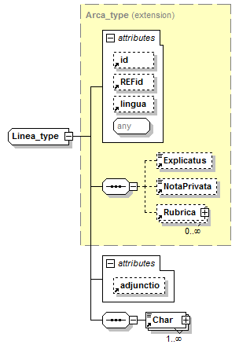
type
extension of Arca_type
properties
base | Arca_type
id | Linea_type-LexDania_2.1
children
Explicatus NotaPrivata Rubrica Char
used by
element | Linea
attributes
Name | Type | Use | Default | Fixed | annotation
id
REFid
lingua
adjunctio
source
<xsd:complexType name="Linea_type" id="Linea_type-LexDania_2.1">
<xsd:complexContent>
<xsd:extension base="Arca_type">
<xsd:sequence>
<xsd:element ref="Char" maxOccurs="unbounded"/>
</xsd:sequence>
<xsd:attribute ref="adjunctio"/>
</xsd:extension>
</xsd:complexContent>
</xsd:complexType>

complexType Nota_type
diagram
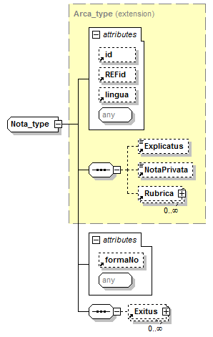
type
extension of Arca_type
properties
base | Arca_type
id | Nota_type-LexDania_2.1
children
Explicatus NotaPrivata Rubrica Exitus
used by
element | Nota
attributes
Name | Type | Use | Default | Fixed | annotation
id
REFid
lingua
formaNo
source
<xsd:complexType name="Nota_type" id="Nota_type-LexDania_2.1">
<xsd:complexContent>
<xsd:extension base="Arca_type">
<xsd:sequence>
<xsd:element ref="Exitus" minOccurs="0" maxOccurs="unbounded"/>
</xsd:sequence>
<xsd:attribute ref="formaNo"/>
<xsd:anyAttribute/>
</xsd:extension>
</xsd:complexContent>
</xsd:complexType>

complexType Rubrica_type
diagram
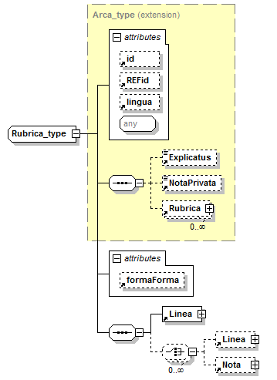
type
extension of Arca_type
properties
base | Arca_type
id | Rubrica_type-LexDania_2.1
children
Explicatus NotaPrivata Rubrica Linea Nota
used by
elements | Rubrica TalerTitel Titel UnderTitel
attributes
Name | Type | Use | Default | Fixed | annotation
id
REFid
lingua
formaForma
source
<xsd:complexType name="Rubrica_type" id="Rubrica_type-LexDania_2.1">
<xsd:complexContent>
<xsd:extension base="Arca_type">
<xsd:sequence>
<xsd:element ref="Linea"/>
<xsd:choice minOccurs="0" maxOccurs="unbounded">
<xsd:element ref="Linea" minOccurs="0"/>
<xsd:element ref="Nota" minOccurs="0"/>
</xsd:choice>
</xsd:sequence>
<xsd:attribute ref="formaForma"/>
</xsd:extension>
</xsd:complexContent>
</xsd:complexType>

complexType Tabula_type
diagram
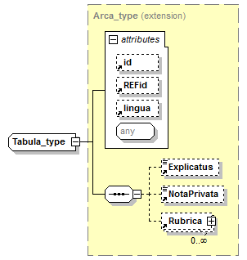
type
extension of Arca_type
properties
base | Arca_type
id | Tabula_type-LexDania_2.1
children
Explicatus NotaPrivata Rubrica
used by
element | Tabula
complexType | Table_type
attributes
Name | Type | Use | Default | Fixed | annotation
id
REFid
lingua
source
<xsd:complexType name="Tabula_type" id="Tabula_type-LexDania_2.1">
<xsd:complexContent>
<xsd:extension base="Arca_type"/>
</xsd:complexContent>
</xsd:complexType>

complexType Xtern_type
diagram
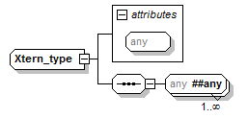
properties
id | Xtern_type-LexDania_2.1
attributes
Name | Type | Use | Default | Fixed | annotation
source
<xsd:complexType name="Xtern_type" id="Xtern_type-LexDania_2.1">
<xsd:sequence>
<xsd:any namespace="##any" maxOccurs="unbounded"/>
</xsd:sequence>
<xsd:anyAttribute/>
</xsd:complexType>

attribute tingdokID
type
xsd:string
properties
id | tingdokID_2.1-MetaFolketing
used by
elements | FTCase ParliamentaryGroup ParliamentarySession
complexTypes | MetaCaseNotice_type MetaFTAgendaItem_type MetaFTAgendaSubItem_type MetaMeeting_type MetaSpeakerMP_type
source
<xsd:attribute name="tingdokID" type="xsd:string" id="tingdokID_2.1-MetaFolketing"/>

element AudioFileFolder
diagram
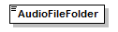
type
xsd:string
properties
content | simple
used by
complexType | MetaMeeting_type
source
<xsd:element name="AudioFileFolder" type="xsd:string"/>

element DateOfSitting
diagram
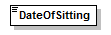
type
xsd:dateTime
properties
content | simple
used by
complexType | MetaMeeting_type
source
<xsd:element name="DateOfSitting" type="xsd:dateTime"/>

element EdixiDocLocation
diagram

type
xsd:string
properties
content | simple
used by
complexType | MetaMeeting_type
source
<xsd:element name="EdixiDocLocation" type="xsd:string"/>

element EdixiStatus
diagram

type
xsd:string
properties
content | simple
used by
complexType | MetaSpeechSegment_type
source
<xsd:element name="EdixiStatus" type="xsd:string"/>

element EndDateTime
diagram
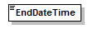
type
xsd:dateTime
properties
content | simple
used by
group | StartEndDateTime_group
source
<xsd:element name="EndDateTime" type="xsd:dateTime"/>

element FTCase
diagram
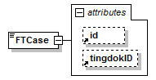
type
extension of xsd:string
properties
content | complex
used by
group | FTCase_group
attributes
Name | Type | Use | Default | Fixed | annotation
id
tingdokID
source
<xsd:element name="FTCase">
<!-- Folketingets sag -->
<xsd:complexType>
<xsd:simpleContent>
<xsd:extension base="xsd:string">
<xsd:attribute ref="id"/>
<xsd:attribute ref="tingdokID"/>
</xsd:extension>
</xsd:simpleContent>
</xsd:complexType>
</xsd:element>

element FTCaseNumber
diagram
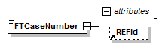
type
extension of xsd:string
properties
content | complex
used by
group | FTCase_group
attributes
Name | Type | Use | Default | Fixed | annotation
REFid
source
<xsd:element name="FTCaseNumber">
<!-- Folketingets sagsnummer (f.eks. "23", så det sammen med CaseType kunne blive L 23) -->
<xsd:complexType>
<xsd:simpleContent>
<xsd:extension base="xsd:string">
<xsd:attribute ref="REFid"/>
</xsd:extension>
</xsd:simpleContent>
</xsd:complexType>
</xsd:element>

element FTCaseStage
diagram
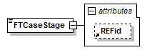
type
extension of xsd:string
properties
content | complex
used by
group | FTCase_group
attributes
Name | Type | Use | Default | Fixed | annotation
REFid
source
<xsd:element name="FTCaseStage">
<!-- Folketingets faseangivelse ifm. behandling af forslag (f.eks. "BEH1") -->
<xsd:complexType>
<xsd:simpleContent>
<xsd:extension base="xsd:string">
<xsd:attribute ref="REFid"/>
</xsd:extension>
</xsd:simpleContent>
</xsd:complexType>
</xsd:element>

element FTCaseType
diagram
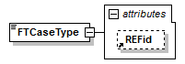
type
extension of xsd:string
properties
content | complex
used by
group | FTCase_group
attributes
Name | Type | Use | Default | Fixed | annotation
REFid
source
<xsd:element name="FTCaseType">
<!-- Folketingets sagstype (f.eks. "L" for lovforslag, så det sammen med CaseNumber kunne blive f.eks. L 23) -->
<xsd:complexType>
<xsd:simpleContent>
<xsd:extension base="xsd:string">
<xsd:attribute ref="REFid"/>
</xsd:extension>
</xsd:simpleContent>
</xsd:complexType>
</xsd:element>

element GroupNameShort
diagram

type
xsd:string
properties
content | simple
used by
complexType | MetaSpeakerMP_type
source
<xsd:element name="GroupNameShort" type="xsd:string"/>

element ItemNo
diagram

type
xsd:string
properties
content | simple
used by
complexType | MetaFTAgendaItem_type
source
<xsd:element name="ItemNo" type="xsd:string"/>

element JointReadingID
diagram

type
xsd:string
properties
content | simple
used by
complexType | MetaFTAgendaItem_type
source
<xsd:element name="JointReadingID" type="xsd:string"/>

element LastModified
diagram
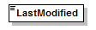
type
xsd:dateTime
properties
content | simple
used by
complexType | MetaSpeechSegment_type
source
<xsd:element name="LastModified" type="xsd:dateTime"/>

element Location
diagram
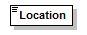
type
xsd:string
properties
content | simple
used by
complexType | MetaMeeting_type
source
<xsd:element name="Location" type="xsd:string"/>

element MeetingNumber
diagram
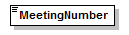
type
xsd:integer
properties
content | simple
used by
complexType | MetaMeeting_type
source
<xsd:element name="MeetingNumber" type="xsd:integer"/>

element MetaCaseNotice
diagram
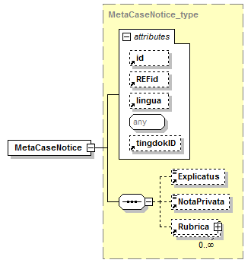
type
MetaCaseNotice_type
properties
content | complex
id | MetaCaseNotice_2.1-MetaFolketing
children
Explicatus NotaPrivata Rubrica
used by
complexType | SagAnmeldelse_type
attributes
Name | Type | Use | Default | Fixed | annotation
id
REFid
lingua
tingdokID
source
<xsd:element name="MetaCaseNotice" type="MetaCaseNotice_type" id="MetaCaseNotice_2.1-MetaFolketing"/>

element MetaFTAgendaItem
diagram
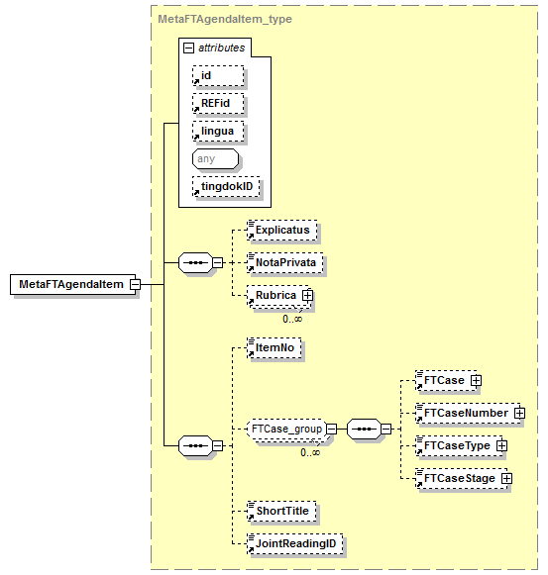
type
MetaFTAgendaItem_type
properties
content | complex
id | MetaFTAgendaItem_2.1-MetaFolketing
children
Explicatus NotaPrivata Rubrica ItemNo FTCase FTCaseNumber FTCaseType FTCaseStage ShortTitle JointReadingID
used by
complexType | DagsordenPunkt_type
attributes
Name | Type | Use | Default | Fixed | annotation
id
REFid
lingua
tingdokID
source
<xsd:element name="MetaFTAgendaItem" type="MetaFTAgendaItem_type" id="MetaFTAgendaItem_2.1-MetaFolketing"/>

element MetaFTAgendaSubItem
diagram
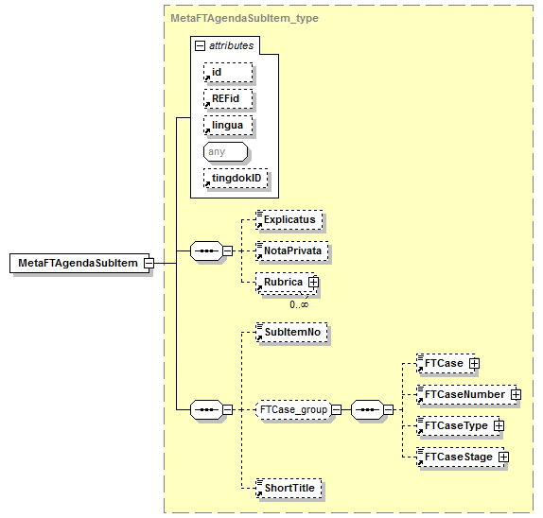
type
MetaFTAgendaSubItem_type
properties
content | complex
id | MetaFTAgendaSubItem_2.1-MetaFolketing
children
Explicatus NotaPrivata Rubrica SubItemNo FTCase FTCaseNumber FTCaseType FTCaseStage ShortTitle
used by
complexType | DagsordenUnderpunkt_type
attributes
Name | Type | Use | Default | Fixed | annotation
id
REFid
lingua
tingdokID
source
<xsd:element name="MetaFTAgendaSubItem" type="MetaFTAgendaSubItem_type" id="MetaFTAgendaSubItem_2.1-MetaFolketing"/>

element MetaMeeting
diagram
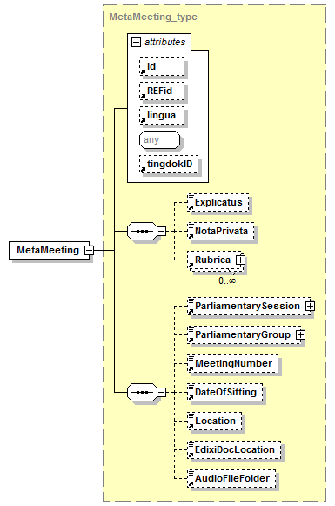
type
MetaMeeting_type
properties
content | complex
id | MetaMeeting_2.1-MetaFolketing
children
Explicatus NotaPrivata Rubrica ParliamentarySession ParliamentaryGroup MeetingNumber DateOfSitting Location EdixiDocLocation AudioFileFolder
used by
complexType | Dokument_type
attributes
Name | Type | Use | Default | Fixed | annotation
id
REFid
lingua
tingdokID
source
<xsd:element name="MetaMeeting" type="MetaMeeting_type" id="MetaMeeting_2.1-MetaFolketing"/>

element MetaSpeakerMP
diagram
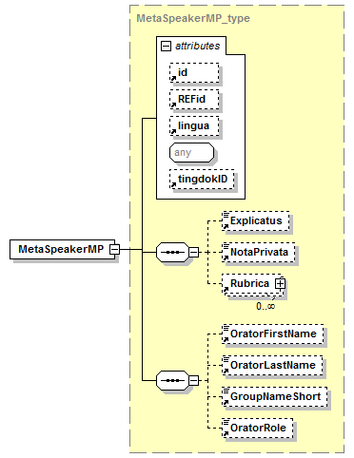
type
MetaSpeakerMP_type
properties
content | complex
id | MetaSpeakerMP_2.1-MetaFolketing
children
Explicatus NotaPrivata Rubrica OratorFirstName OratorLastName GroupNameShort OratorRole
used by
complexType | Taler_type
attributes
Name | Type | Use | Default | Fixed | annotation
id
REFid
lingua
tingdokID
source
<xsd:element name="MetaSpeakerMP" type="MetaSpeakerMP_type" id="MetaSpeakerMP_2.1-MetaFolketing"/>

element MetaSpeechSegment
diagram
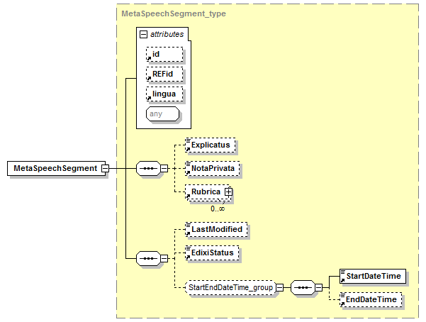
type
MetaSpeechSegment_type
properties
content | complex
id | MetaSpeechSegment_2.1-MetaFolketing
children
Explicatus NotaPrivata Rubrica LastModified EdixiStatus StartDateTime EndDateTime
used by
complexType | TaleSegment_type
attributes
Name | Type | Use | Default | Fixed | annotation
id
REFid
lingua
source
<xsd:element name="MetaSpeechSegment" type="MetaSpeechSegment_type" id="MetaSpeechSegment_2.1-MetaFolketing"/>

element OratorFirstName
diagram
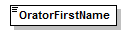
type
xsd:string
properties
content | simple
used by
complexType | MetaSpeakerMP_type
source
<xsd:element name="OratorFirstName" type="xsd:string"/>

element OratorLastName
diagram
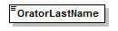
type
xsd:string
properties
content | simple
used by
complexType | MetaSpeakerMP_type
source
<xsd:element name="OratorLastName" type="xsd:string"/>

element OratorRole
diagram
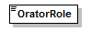
type
xsd:string
properties
content | simple
used by
complexType | MetaSpeakerMP_type
source
<xsd:element name="OratorRole" type="xsd:string"/>

element ParliamentaryGroup
diagram
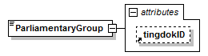
type
extension of xsd:string
properties
content | complex
used by
complexType | MetaMeeting_type
attributes
Name | Type | Use | Default | Fixed | annotation
tingdokID
source
<xsd:element name="ParliamentaryGroup">
<!-- Parlamentarisk gruppe (f.eks. Folketinget) -->
<xsd:complexType>
<xsd:simpleContent>
<xsd:extension base="xsd:string">
<xsd:attribute ref="tingdokID"/>
</xsd:extension>
</xsd:simpleContent>
</xsd:complexType>
</xsd:element>

element ParliamentarySession
diagram
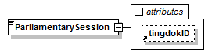
type
extension of xsd:integer
properties
content | complex
used by
complexType | MetaMeeting_type
attributes
Name | Type | Use | Default | Fixed | annotation
tingdokID
source
<xsd:element name="ParliamentarySession">
<!-- Folketingssamling -->
<xsd:complexType>
<xsd:simpleContent>
<xsd:extension base="xsd:integer">
<xsd:attribute ref="tingdokID"/>
</xsd:extension>
</xsd:simpleContent>
</xsd:complexType>
</xsd:element>

element ShortTitle
diagram
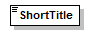
type
xsd:string
properties
content | simple
used by
complexTypes | MetaFTAgendaItem_type MetaFTAgendaSubItem_type
source
<xsd:element name="ShortTitle" type="xsd:string"/>

element StartDateTime
diagram
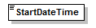
type
xsd:dateTime
properties
content | simple
used by
group | StartEndDateTime_group
source
<xsd:element name="StartDateTime" type="xsd:dateTime"/>

element SubItemNo
diagram

type
xsd:string
properties
content | simple
used by
complexType | MetaFTAgendaSubItem_type
source
<xsd:element name="SubItemNo" type="xsd:string"/>

group FTCase_group
diagram
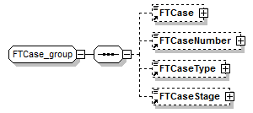
properties
id | FTCase_group_2.1-MetaFolketing
children
FTCase FTCaseNumber FTCaseType FTCaseStage
used by
complexTypes | MetaFTAgendaItem_type MetaFTAgendaSubItem_type
source
<xsd:group name="FTCase_group" id="FTCase_group_2.1-MetaFolketing">
<xsd:sequence>
<xsd:element ref="FTCase" minOccurs="0"/>
<!-- Folketingets sag -->
<xsd:element ref="FTCaseNumber" minOccurs="0"/>
<!-- Folketingets sagsnummer -->
<xsd:element ref="FTCaseType" minOccurs="0"/>
<!-- Folketingets sagstype -->
<xsd:element ref="FTCaseStage" minOccurs="0"/>
<!-- Folketingets faseangivelse ifm. forslag -->
</xsd:sequence>
</xsd:group>

group StartEndDateTime_group
diagram
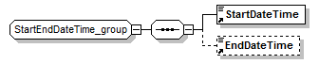
properties
id | StartEndDateTime_group_2.1-MetaFolketing
children
StartDateTime EndDateTime
used by
complexType | MetaSpeechSegment_type
source
<xsd:group name="StartEndDateTime_group" id="StartEndDateTime_group_2.1-MetaFolketing">
<xsd:sequence>
<xsd:element ref="StartDateTime"/>
<!-- Start tid -->
<xsd:element ref="EndDateTime" minOccurs="0"/>
<!-- Slut Tid -->
</xsd:sequence>
</xsd:group>

complexType MetaCaseNotice_type
diagram
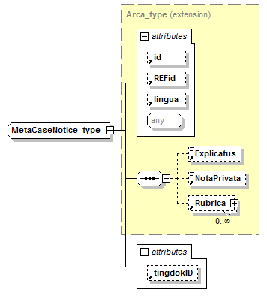
type
extension of Arca_type
properties
base | Arca_type
id | MetaCaseNotice_type_2.1-MetaFolketing
children
Explicatus NotaPrivata Rubrica
used by
element | MetaCaseNotice
attributes
Name | Type | Use | Default | Fixed | annotation
id
REFid
lingua
tingdokID
source
<xsd:complexType name="MetaCaseNotice_type" id="MetaCaseNotice_type_2.1-MetaFolketing">
<xsd:complexContent>
<xsd:extension base="Arca_type">
<xsd:attribute ref="tingdokID"/>
</xsd:extension>
</xsd:complexContent>
</xsd:complexType>

complexType MetaFTAgendaItem_type
diagram
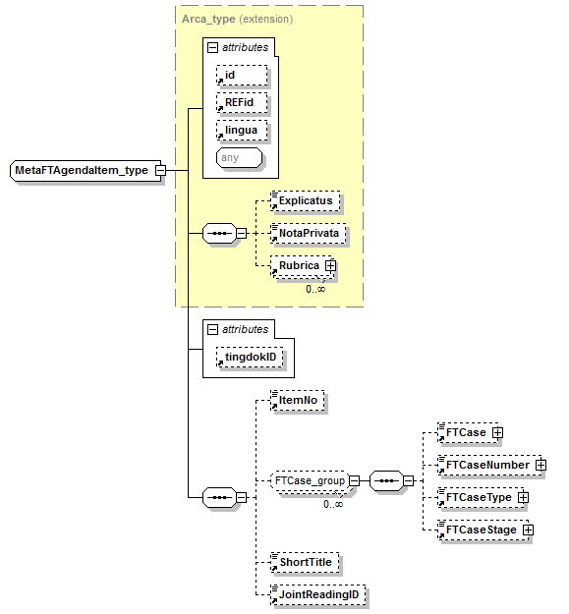
type
extension of Arca_type
properties
base | Arca_type
id | MetaFTAgendaItem_type_2.1-MetaFolketing
children
Explicatus NotaPrivata Rubrica ItemNo FTCase FTCaseNumber FTCaseType FTCaseStage ShortTitle JointReadingID
used by
element | MetaFTAgendaItem
attributes
Name | Type | Use | Default | Fixed | annotation
id
REFid
lingua
tingdokID
source
<xsd:complexType name="MetaFTAgendaItem_type" id="MetaFTAgendaItem_type_2.1-MetaFolketing">
<xsd:complexContent>
<xsd:extension base="Arca_type">
<xsd:sequence>
<xsd:element ref="ItemNo" minOccurs="0"/>
<xsd:group ref="FTCase_group" minOccurs="0" maxOccurs="unbounded"/>
<xsd:element ref="ShortTitle" minOccurs="0"/>
<xsd:element ref="JointReadingID" minOccurs="0"/>
</xsd:sequence>
<xsd:attribute ref="tingdokID"/>
</xsd:extension>
</xsd:complexContent>
</xsd:complexType>

complexType MetaFTAgendaSubItem_type
diagram
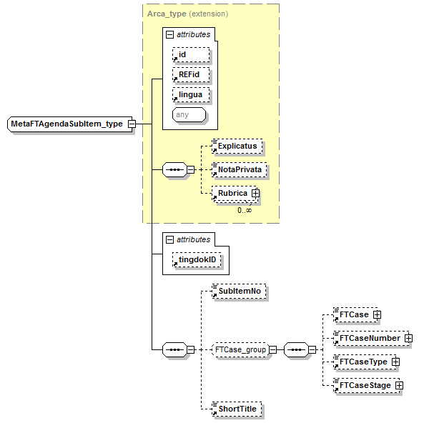
type
extension of Arca_type
properties
base | Arca_type
id | MetaFTAgendaSubItem_type_2.1-MetaFolketing
children
Explicatus NotaPrivata Rubrica SubItemNo FTCase FTCaseNumber FTCaseType FTCaseStage ShortTitle
used by
element | MetaFTAgendaSubItem
attributes
Name | Type | Use | Default | Fixed | annotation
id
REFid
lingua
tingdokID
source
<xsd:complexType name="MetaFTAgendaSubItem_type" id="MetaFTAgendaSubItem_type_2.1-MetaFolketing">
<xsd:complexContent>
<xsd:extension base="Arca_type">
<xsd:sequence>
<xsd:element ref="SubItemNo" minOccurs="0"/>
<xsd:group ref="FTCase_group" minOccurs="0"/>
<xsd:element ref="ShortTitle" minOccurs="0"/>
</xsd:sequence>
<xsd:attribute ref="tingdokID"/>
</xsd:extension>
</xsd:complexContent>
</xsd:complexType>

complexType MetaMeeting_type
diagram
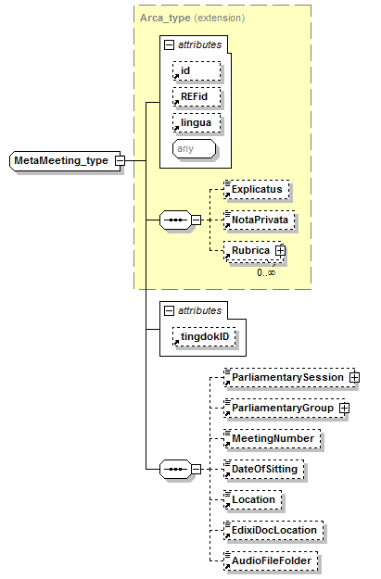
type
extension of Arca_type
properties
base | Arca_type
id | MetaMeeting_type_2.1-MetaFolketing
children
Explicatus NotaPrivata Rubrica ParliamentarySession ParliamentaryGroup MeetingNumber DateOfSitting Location EdixiDocLocation AudioFileFolder
used by
element | MetaMeeting
attributes
Name | Type | Use | Default | Fixed | annotation
id
REFid
lingua
tingdokID
source
<xsd:complexType name="MetaMeeting_type" id="MetaMeeting_type_2.1-MetaFolketing">
<xsd:complexContent>
<xsd:extension base="Arca_type">
<xsd:sequence>
<xsd:element ref="ParliamentarySession" minOccurs="0"/>
<xsd:element ref="ParliamentaryGroup" minOccurs="0"/>
<xsd:element ref="MeetingNumber" minOccurs="0"/>
<xsd:element ref="DateOfSitting" minOccurs="0"/>
<xsd:element ref="Location" minOccurs="0"/>
<xsd:element ref="EdixiDocLocation" minOccurs="0"/>
<xsd:element ref="AudioFileFolder" minOccurs="0"/>
</xsd:sequence>
<xsd:attribute ref="tingdokID"/>
</xsd:extension>
</xsd:complexContent>
</xsd:complexType>

complexType MetaSpeakerMP_type
diagram
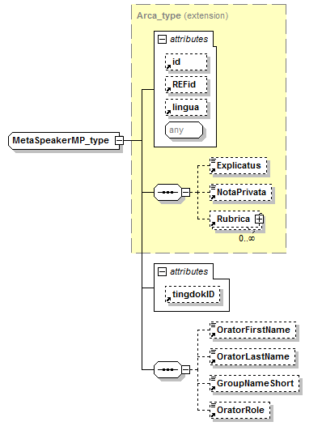
type
extension of Arca_type
properties
base | Arca_type
id | MetaSpeakerMP_type_2.1-MetaFolketing
children
Explicatus NotaPrivata Rubrica OratorFirstName OratorLastName GroupNameShort OratorRole
used by
element | MetaSpeakerMP
attributes
Name | Type | Use | Default | Fixed | annotation
id
REFid
lingua
tingdokID
source
<xsd:complexType name="MetaSpeakerMP_type" id="MetaSpeakerMP_type_2.1-MetaFolketing">
<xsd:complexContent>
<xsd:extension base="Arca_type">
<xsd:sequence>
<xsd:element ref="OratorFirstName" minOccurs="0"/>
<xsd:element ref="OratorLastName" minOccurs="0"/>
<xsd:element ref="GroupNameShort" minOccurs="0"/>
<xsd:element ref="OratorRole" minOccurs="0"/>
</xsd:sequence>
<xsd:attribute ref="tingdokID"/>
</xsd:extension>
</xsd:complexContent>
</xsd:complexType>

complexType MetaSpeechSegment_type
diagram
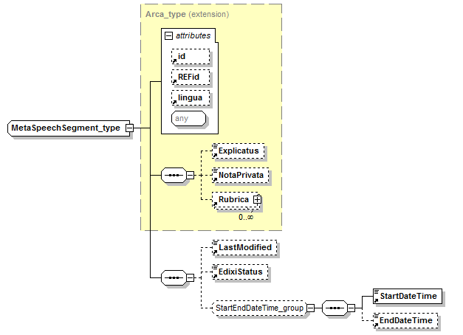
type
extension of Arca_type
properties
base | Arca_type
id | MetaSpeechSegment_type_2.1-MetaFolketing
children
Explicatus NotaPrivata Rubrica LastModified EdixiStatus StartDateTime EndDateTime
used by
element | MetaSpeechSegment
attributes
Name | Type | Use | Default | Fixed | annotation
id
REFid
lingua
source
<xsd:complexType name="MetaSpeechSegment_type" id="MetaSpeechSegment_type_2.1-MetaFolketing">
<xsd:complexContent>
<xsd:extension base="Arca_type">
<xsd:sequence>
<xsd:element ref="LastModified" minOccurs="0"/>
<xsd:element ref="EdixiStatus" minOccurs="0"/>
<xsd:group ref="StartEndDateTime_group" minOccurs="0"/>
</xsd:sequence>
</xsd:extension>
</xsd:complexContent>
</xsd:complexType>

XML Schema documentation generated by XMLSpy Schema Editor http://www.altova.com/xmlspy

